Initial Plan

File Synchronization and Backup Tool

v1.0

Acquirer : CTIS
Prepared By :
Ege ILICAK
Cenk AKIN
Murat ÇINAR

Serkan AKŞİT
Date of Issue : October 17, 2008

File Synchronization and Backup Tool
Signatures

_________________________
Ege Ilıcak – Group Member

_________________________
Cenk Akın – Group Member

_________________________
Murat Çınar – Group Member

_________________________
Serkan Akşit – Group Member

_________________________ __________________________
Beyhan Akporay Vural Polat
Senior Project Manager Project Consultant

Change History

Project Name | Version | Person Responsible | Date | Changes
File Synchronization and Backup Tool | 1.0 | Ege Ilıcak | 17-10-2008 | Initial release

PREFACE
This Initial Plan document is the first draft of the Software Project Management Plan of File Synchronization and Backup Tool project, which aims on synchronization of files between drives, computers and PDAs (personal digital assistant).

Initial Plan gives a brief summary about the File Synchronization and Backup Tool project. Initial plan includes the purpose, scope and the objectives of the project; the project assumptions and constraints; a list of project deliverables and a table about the project schedule and the plan for evolution of the SPMP.

In addition to these, initial plan gives information about the evolution of the SPMP and project organization including the project’s external interfaces, internal structure and organization’s roles and responsibilities.

This document is prepared according to “IEEE Standard for Software Project Management Plans”.
Table Of Contents

List Of Figures 6
List Of Tables 7
1. OVERVIEW 8
1.1 Project Summary 8
1.1.1 Purpose, Scope, and Objectives 8
1.1.2 Assumptions and Constraints 8
1.1.3 Project Deliverables 9
1.1.4 Schedule and Budget Summary 9
1.2 Evolution of the SPMP 17
2. REFERENCES 18
3. DEFINITIONS 19
4. PROJECT ORGANIZATON 20
4.1 External Interfaces 20
4.2 Internal Structure 21
4.3 Roles and responsibilities 21

List Of Figures
Figure 1 – Gantt Chart 16
Figure 2 – External Interfaces 20
Figure 3 – Internal Structure 21

List Of Tables
Table 1 – Project Deliverables 9
Table 2 – Schedule and Budget Summary 9
Table 3 – Work Breakdown Structure 11
Table 4 – Definitions 19
Table 5 – Roles and Responsibilities 22
Table 6 – Responsibilities of Group Members 23

1. OVERVIEW
This part will introduce the project summary that is about file synchronization and backup tool.

1.1 Project Summary

This part will introduce the purpose, scope, and objectives; assumptions and constraints; project deliverables and schedule about the project.

1.1.1 Purpose, Scope, and Objectives

Nowadays, decreases of the prices of computers bring us to have more than one computer in users’ homes or offices. Therefore, users need to communicate between two or more computers. In this purpose, file synchronization and backup tool provides to transfer and update data and files between their computers.

The purpose of this project is transmitting files and other important data over cables through drive-to-drive, PC-to-PC and also PC to PDA (which has Windows Mobile 6.0 or Windows Mobile 6.1.) devices over USB port.

In addition to these connection types, file synchronization can be established over the TCP/IP protocol between two PCs, which are even not on the same network.

1.1.2 Assumptions and Constraints

Assumptions of the project are described below:

- The product will be worked on every computer which is in same network.
- Every Thursday there will be a meeting with the project manager to discuss the improvements and observing the development process of the project.
- Computers are working correctly and without any bugs, without freezing and all of the hardware are configured correctly and having enough resource to handle our software.
- In the spring semester development period of the project will start.
- Coding and testing of the project will be done in spring semester.
- Computer Technologies and Information Systems (CTIS) department, the senior project manager Beyhan AKPORAY, the project consultant Vural POLAT could change the deadline dates of these documents.

Constraints of the project are described below:

- .NET Framework 3.5 has to be installed to the client computers.
- .NET Sync Framework 1.0 Mobile has to be installed for PDAs.
- .NET Sync Framework 1.0 has to be installed for Computers
- .NET Compact Framework 3.5 has to be installed to the PDAs.
- Windows Mobile 6.0 or higher Operating System has to be installed to the PDA.
- Development Environment is going to be Microsoft Visual Studio 2008.
- Database Management System is going to be MS SQL Server 2005 or higher.
- Backward compatibility will be provided with Windows XP.

1.1.3 Project Deliverables

Product | Delivery Information
Initial Plan : | This document will be delivered at 17th October 2008 to Beyhan AKPORAY.
Software Requirement Specification: | A Software Requirements Specification (SRS) is a complete description of the behavior of the system to be developed. SRS will be delivered until 31st October 2008 to Beyhan AKPORAY.
Software Project Management Plan: | An SPMP is the controlling document for managing a software project; it defines the technical and managerial processes necessary to develop software work products that satisfy the product requirements. SPMP will be delivered until  21st November 2008 to Beyhan AKPORAY.
Software Design Document: | Software Design Document (SDD) is a comprehensive software design model consisting of four distinct but interrelated activities: data design, architectural design, interface design, and procedural design. SDD will be delivered until 23rd December 2008 to Beyhan AKPORAY.
Prototype Implementation And Demo: | The prototype and the demo are going to be prepared in January 2009 and delivered to Beyhan AKPORAY.
Table 1 – Project Deliverables

1.1.4 Schedule and Budget Summary

Task Date | Task Name
17th October 2008 | Initial Plan
31st October 2008 | Software Requirements Specification (SRS)
21st November 2008 | Software Project Management Plan (SPMP)
23rd December 2008 | Software Design Description (SDD)
January 2009 | Prototype Implementation And Demo
Table 2 – Schedule and Budget Summary

Work Breakdown Structure

Task No. | Task Name
0.0 | File Synchronization and Backup Tool
1.0 | Initial Plan
1.1 | Preparing the Initial Plan
1.2 | Meeting with the Consultant (Vural Polat)
1.3 | Delivering the Initial Plan
2.0 | Requirements
2.1 | Requirements Elicitation
2.1.1 | Meeting with the Consultant
2.1.2 | Problem Description for file synchronization
2.1.3 | Searching for problem solution
2.1.3.1 | Analyze similar synchronization software
2.2 | Requirements Analysis
2.2.1 | Analyzing eligible frameworks
2.2.1.1 | Analyzing synchronization compatible frameworks for PCs
2.2.1.2 | Analyzing synchronization compatible frameworks for PDAs
2.3 | Delivering Software Requirements Specification (SRS) Document
3.0 | Software Project Management Plan (SPMP)
3.1 | Managerial Process Plans
3.1.1 | Project Start-up Plan
3.1.2 | Work Plan
3.1.3 | Control Plan
3.1.4 | Risk Management Plan
3.1.5 | Closeout Plan
3.2 | Technical Process Plans
3.2.1 | Infrastructure Plan
3.2.1.1 | Providing Hardware System for File Synchronization and Backup Tool Project
3.2.1.2 | Detecting the Operating System for File Synchronization and Backup Tool Project
3.2.1.3 | Setting up the Network System
3.2.1.4 | Establishing Software System for File Synchronization and Backup Tool Project
3.3 | Supporting Process Plans
3.4 | Additional Plans
3.5 | Delivering the Software Project Management Plan (SPMP)
4.0 | Software Design and Documentation (SDD)
4.1 | Software Design of File Synchronization and Backup Tool
4.1.1 | Problem-solving and planning for a File Synchronization and Backup Tool
4.2 | Interface Design of File Synchronization and Backup Tool
4.2.1 | Design of interfaces that will be created during the software development
4.3 | Database Design
4.3.1 | Designing the user database
4.3.2 | Designing the logging database
4.4 | Architecture Design
4.4.1 | Identifying the Synchronization classes
4.4.2 | Identifying the Connection classes
4.4.3 | Identifying the Synchronization methods
4.4.4 | Identifying the Event methods
4.4.5 | Identifying the relations between classes
4.4.6 | Identifying the relations between classes and methods
4.5 | Documentation
4.5.1 | Preparing Software Design Document (SDD)
4.5.2 | Delivering the Software Design Document (SDD)
5.0 | Prototype Implementation and Demo
5.1 | Implementation of Demo
5.2 | Presentation of Demo
6.0 | Hardware System
6.1 | Obtaining PCs
6.2 | Obtaining the File Server
6.3 | Obtaining the PDA
7.0 | Software Development
7.1 | Implementation of Graphical User Interfaces
7.1.1 | Implementation of Graphical User Interfaces for Drive-to-Drive Synchronization
7.1.2 | Implementation of Graphical User Interfaces for PC-to-PC Synchronization
7.1.3 | Implementation of Graphical User Interfaces for PC to PDA Synchronization
7.1.4 | Implementation of Graphical User Interfaces for Synchronization over TCP/IP connection
7.2 | Implementation of User List Database and Logging Database
7.3 | Implementation of Filename Check Process
7.4 | Implementation of Tracking Logs
7.5 | Implementation of Drive-to-Drive Synchronization
7.6 | Implementation of PC-to-PC Synchronization
7.7 | Implementation of PC-to-PDA Synchronization
7.8 | Implementation of Server Software
7.9 | Implementation of Synchronization over TCP/IP connection
7.10 | Review of Implemented Database
7.11 | Implementation of Backup Tool
8.0 | User Manual
8.1 | Preparing the User Manual
9.0 | Testing
9.1 | Testing Documentations
9.2 | Fixing Errors and Bugs
10.0 | Distribution of the final product
10.1 | Compiling the Project Documents
10.2 | Delivering the Software Product
Table 3 – Work Breakdown Structure

Gantt Chart

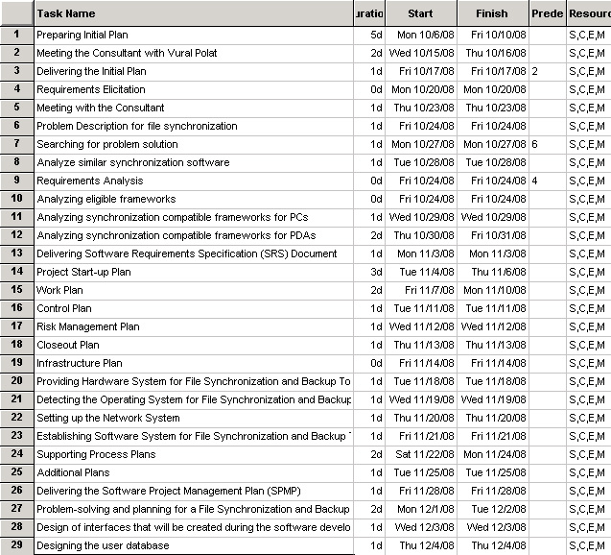
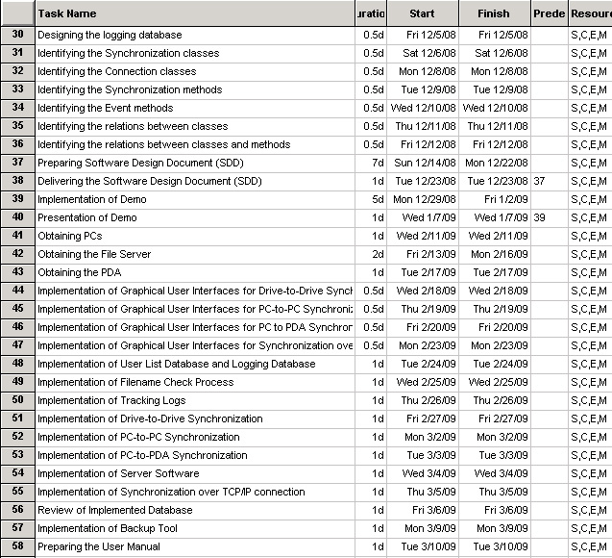
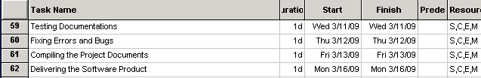

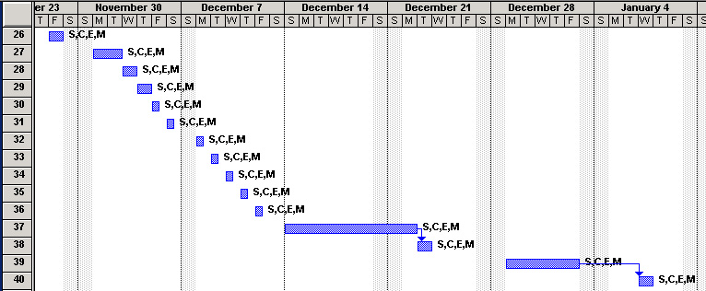
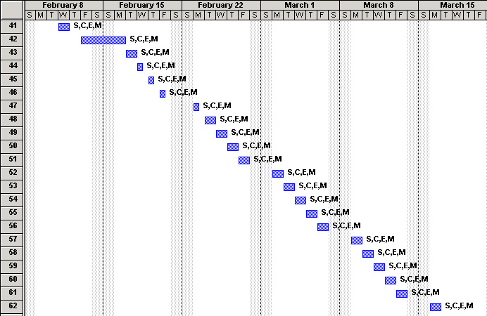

Figure 1 – Gantt Chart
1.2 Evolution of the SPMP

This document is the first version of the Software Project Management Plan and it is called as Initial Plan. SPMP document will be updated and disseminated as hard and soft copies whenever required considering deadlines.

The updates will be listed on a table with the due dates for the upcoming revisions.

Whenever an update is required, the project team will be in contact with the acquirer immediately, analyze the problems and the changes carefully. After analyzing the problems, the project team will be working on problems to find the best solution possible for the problem in the shortest period of time.

While creating the solution, all required changes could be done in SRS such as changing one or more of the requirements to satisfy the acquirer.

After planning and implementing the best solution for the problem, every detail will be specifically considered and will be included in the plan.
2. REFERENCES

- IEEE STD 1058 – 1998, IEEE Standard for Software Project Management Plans
- Answers.com - http://www.answers.com/
- Work Breakdown Structure. NetMBA - Business Knowledge Center. 15 October, 2008 from http://www.netmba.com/operations/project/wbs/

3. DEFINITIONS
The list of definitions that will be used in the document.

CTIS : | Computer Technology and Information Systems
IEEE : | Institute of Electrical and Electronics Engineers
FSBT : | File Synchronization and Backup Tool
MCF : | Microsoft Compact Framework
MSF : | Microsoft Sync Framework
WMBL : | Windows Mobile
DB : | Database
SYNC : | Synchronization
PL : | Programming language of the system
SDD : | Software Design Document
SRS : | Software Requirements Specification
SPMP : | Software Project Management Plan
Table 4 – Definitions

4. PROJECT ORGANIZATON
This section goes into detail of the external interfaces, describes the project’s internal structure and determines the roles and responsibilities for the project.

4.1 External Interfaces

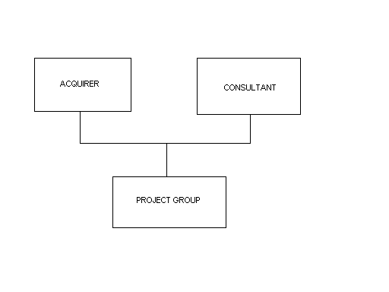
Figure 2 – External Interfaces

Bilkent University (Acquirer): CTIS Department
CTIS (Consultant): Vural Polat

4.2 Internal Structure
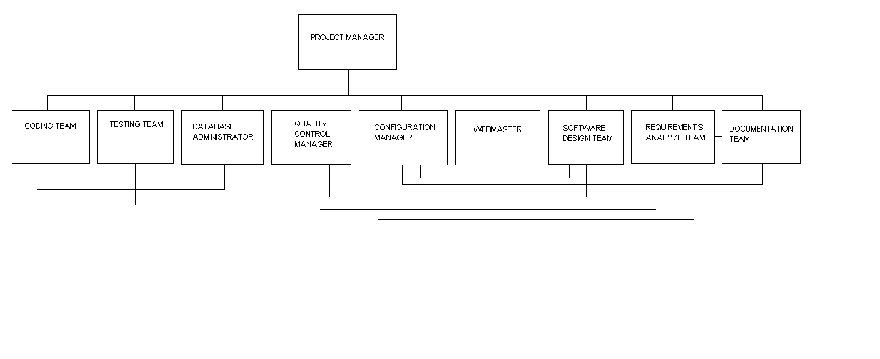
Figure 3 – Internal Structure

4.3 Roles and responsibilities

The table of team members’ roles and responsibilities.

Name Surname | Roles & Responsibilities
Ege ILICAK | Project Manager  Configuration Manager  Head of Coding Team  Software Development Specialist  Requirements Analyzer
Murat ÇINAR | Quality Manager  Configuration Manager  Software Development Specialist  Requirements Analyzer  Head of Documentation Team
Cenk AKIN | Webmaster  User Interface Designer  Configuration Manager  Test Engineer  Software Development Specialist  Requirements Analyzer
Serkan AKŞİT | Configuration Manager  Test Engineer  DB Administrator  Software Development Specialist  Requirements Analyzer
Table 5 – Roles and Responsibilities

Coding Team | The team that implements the codes of the software.
Configuration Manager | The member who is responsible for developing process plans and procedures.
Database Administrator | The member who is responsible for design and implementation of the database of the project.
Documentation Team | The team that is responsible for writing and delivering documentations to the customer.
Project Manager | The member who is responsible for administration of technical and managerial process of the project.
Quality Manager | The member who is responsible for determining ways to improve the software development process.
Requirements Analyzer | The member who gathers and analyzes software requirements and process the requirements for the software project.
Software Development Specialist | Member who develops the system by interacting with the customer.
Test Team | The team that tests the system for bugs and exploits.
User Interface Designer | The member who designs the graphical user interface of the software.
Webmaster | The member who is responsible for the functionality and design of the website of the project.
Table 6 – Responsibilities of Group Members

