Software Design Description

File Synchronization and Backup Tool
v1.0

Acquirer : CTIS
Prepared By : Ege Ilıcak
Cenk Akın
Murat Çınar

Serkan Akşit
Date of Issue : 05 January 2009

Change History

Project Name | Version | Person Responsible | Date | Changes
File Synchronization and Backup Tool | 1.0 | Ege Ilıcak | 05-01-2009 | Initial Release

Table of Contents

1. Introduction 6
1.1 Overview 6
1.2 References 6
1.3 Definitions and Acronyms 6
2. Design Considerations 7
2.1 Assumptions 7
2.2 Constraints 7
2.3 Design Methodology 7
3. System Overview 8
4. System Design 10
4.1 Design Goals 10
4.2 System Decomposition 10
4.3 Subsystems Mapping 13
4.4 Data Management 13
4.5 Security Management 13
4.6 Control Flow 14
4.7 Boundary Conditions 14
5. Object Design 15
5.1 Client 15
5.1.1 Description of Client Package 16
5.1.2 Design Class Diagram 17
5.1.3 Sequence Diagram(s) 18
5.2 Server 18
5.2.1 Description of Server Package 18
5.2.2 Design Class Diagram 19
5.2.3 Sequence Diagram 19
6. Traceability Matrix 20

List of Figures
Figure 1 – Use Case Context Diagram 9
Figure 2 – Client Operations Decomposition 11
Figure 3 – Server Operations Decomposition 12
Figure 4 – Subsystems Mapping 13
Figure 5 – design pattern 15
Figure 6 – Design Class Diagram of Client Package 17
Figure 7 – Sequence Diagram of the Client Package 18
Figure 8 – Design Class Diagram of the Server Package 19
Figure 9 – Sequence Diagram of the Server Package 19

List of Tables

Table 1 – Definitions and Acronyms 6
Table 2 – Design Components 20
Table 3 – Traceability Matrix 20

1. Introduction

This part includes the overview, references, definitions and acronyms of the SDD document.

1.1 Overview

There is a need to write an SDD document to improve the software development quality of the project. In order to do this, Beyhan AKPORAY determined certain standards to help the software developers, to improve the quality of the process and decrease the complexity of the project development process.

By the help of the SDD document, the time required to develop a product had decreased dramatically. SDD determines the design of the product and describes the software structure, software components, interfaces and data necessary for the implementation phase of the FSBT in detail.

1.2 References

- Software Requirement Specification Document v1.0
- http://en.wikipedia.org/wiki/Three_tier

1.3 Definitions and Acronyms

The following table will describe the definitions and acronyms of the File Synchronization and Backup Tool.

CTIS : | Computer Technology and Information Systems
IEEE : | Institute of Electrical and Electronics Engineers
FSBT : | File Synchronization and Backup Tool
MCF : | Microsoft Compact Framework
MSF : | Microsoft Sync Framework
WMBL : | Windows Mobile
DB : | Database
SYNC : | Synchronization
PL : | Programming language of the system
SDD : | Software Design Document
SRS : | Software Requirements Specification
SPMP : | Software Project Management Plan

Table 1 – Definitions and Acronyms

2. Design Considerations

This chapter includes the assumptions, constraints and the design methodology of the system.

2.1 Assumptions

- Microsoft SQL SERVER 2005 will be installed to the server side of the File Synchronization and Backup Tool Project and all of the updates of the necessary software will be installed.
- Microsoft Visual Studio 2008 will be used during the design of the software product.
- The design of the software product will be developed on the computers of the developer team.
- Microsoft Windows Vista and XP operating systems will be used during the design of the File Synchronization and Backup Tool.
- Microsoft .NET Framework 3.5 will be installed to the computers of the clients and file server.

2.2 Constraints

- System has to support up to 50 users at the same time.
- Microsoft Visual Studio 2008 will be used during the design of the software product.
- Data has to be transmitted securely (data will be encrypted) over TCP/IP connection type of synchronization.
- Software product has to keep logs of the synchronization done by the user.
- Logs have to be kept in an XML file.
- User has to sign-up for synchronization over TCP/IP connection.

2.3 Design Methodology

All class diagrams; sequence diagrams are drawn with Microsoft Visio 2003 software tool.

Separating the main subsystems of FSBT project into modules develops the design technique and these modules include their own classes and objects related only with their unique modules. All of the modules have their detailed class diagrams to show which classes and objects they are composed of and their relationships, associations and dependencies between them. Sequence diagrams are included to show the dynamic interactions between objects that are unique to their own modules.

3. System Overview

System overview describes the system structure, functionality and the product features.

Functionalities of the FSBT system are synchronizing files from drive-to-drive, PC-to-PC both on a local area network connection and over a TCP/IP connection. Also, synchronizing files between a PC and a PDA device, which has Windows Mobile 5.0, Windows Mobile 6.0 or Windows Mobile 6.1 Operating Systems using the USB port.

System features of the FSBT are listed below:

- Synchronizing drive to drive on the same PC.
  - User can synchronize two folders in the same PC.
  - The system will create log files to keep the track of the synchronization.
- Synchronizing folders in a Local Area Network (LAN).
  - User can synchronize two folders in the same local area network.
  - The system will create log files to keep the track of the synchronization.
- Synchronizing folders between PC and PDA device.
  - User can synchronize two folders between a PC and a PDA.
  - The system will create log files to keep the track of the synchronization.
- Synchronizing folders between two PCs over Internet.
  - User can synchronize two folders between two PCs using TCP/IP connection.
  - The system will create log files to keep the track of the synchronization.
- Taking a backup of a folder on a PC.
  - User can take a backup of a folder in a PC.
  - The system will create log files to keep the track of the synchronization.

Use case context diagram of the FSBT system:

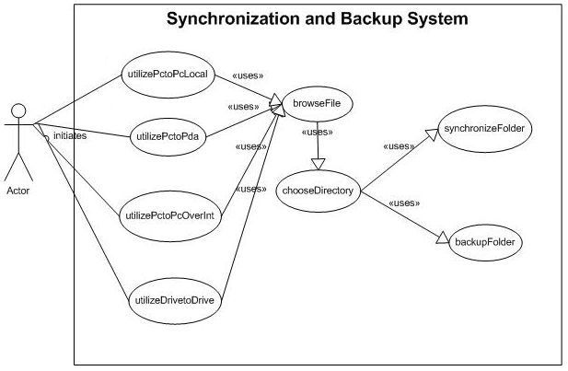

Figure 1 – Use Case Context Diagram

4. System Design

In the following part, system design of the File Synchronization and Backup Tool will be described in detail.

4.1 Design Goals

Design goals are qualities that enable us to prioritize the development of the system. Design goals originate from the nonfunctional requirements specified during requirements elicitation and from technical and management goals specified by the project.

- FSBT will use the operating system resources as less as possible.
- FSBT will be available 7/24.
- FSBT will interact with the user with the highest performance possible.
- Performance of the synchronization over TCP/IP connection will depend on the connection speed of the user.
- Performance of the FSBT will depend on the performance of the user’s system.
- FSBT will be compatible with Windows Mobile 5.0 or higher for PDA devices.
- FSBT will be compatible with Windows XP or higher for PCs.

4.2 System Decomposition

The purpose of this decomposition activity is to divide the system in self-contained components. FSBT project has 2 subsystems. These are client operations and server operations. These subsystems are identified from the functional requirements of the FSBT and from the analysis model.

The responsibilities of these subsystems are listed below:

Responsibilities of Client Operations
- Pc to Pc Synchronization
  - Synchronization over Internet
  - Local Synchronization
- Authentication
- Pc to PDA Synchronization
- Drive to Drive Synchronization
- Backup

Responsibilities of Server Operations
- Creating a Database Connection
- User Storage
- Sending and Receiving Files
- Maintaining Security
- Encryption and Decryption of files
- Creating a Socket Connection

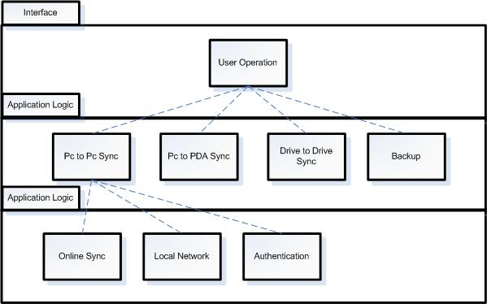

Figure 2 – Client Operations Decomposition

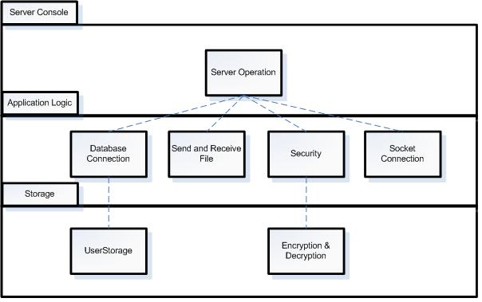
Figure 3 – Server Operations Decomposition

4.3 Subsystems Mapping

This section gives information about physical structure of the system and the communication between them.

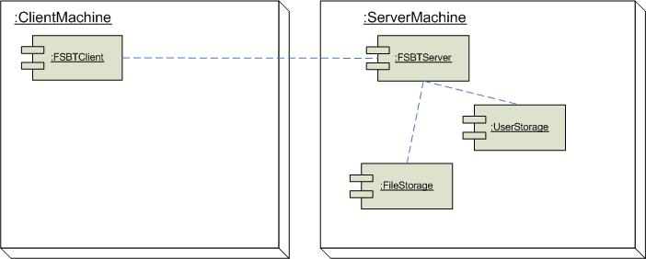

Figure 4 – Subsystems Mapping

4.4 Data Management

In FSBT, there will be “User” object that will trigger the synchronization event. Files that will be synchronized over TCP/IP connection will be stored in the file server, which will be provided by the project team. Log data of the synchronization over TCP/IP connection will be stored both in the User’s PC and the file server.

The database of the User list will be stored in the file server, which will be provided by the project team. This database will store the list and attributes of the Users. In addition, file server will store the shared folder that was created by handshake between two Users.

4.5 Security Management

In FSBT, security of synchronization over local area network connection will be provided by the access permissions given by the local area network admin.

The software will provide security of the synchronization over TCP/IP connection. The files will be encrypted when uploading to the file server and the encrypted data will be stored in the shared folder of the users. When the other user wants to synchronize the files, encrypted files will be downloaded from the server and will be decrypted on the user side of the synchronization.

4.6 Control Flow

Control flow of the FSBT describes how system processes and threads are managed. Users can select pc-to-pc, pc to pda, backup and drive-to-drive synchronization choices. Each of the synchronization type triggers a different thread. Selected thread delegates the necessary synchronization functions.
When pc to pda, backup or drive-to-drive synchronization type is selected, file browser window is shown. User selects two directories from his/her either computer or PDA device. After two folders are selected, synchronize button triggers the “syncFolders” function, which synchronizes the selected folders.

When pc-to-pc over Internet option selected, login interface is shown. During the registration, system sends username, e-mail and password to the database that is located in the file server. A function, which is working asynchrony on the file server listens the packages coming from the clients. After receiving incoming packages, user information is send to the SQL server by connection functions.

In addition to these, file server listens client requests regularly. A listening function is working on a different thread and file server allocates a new thread for each client, allowing the parallel handling of requests. Clients can either send or download a shared folder to the file server. When a client sends file to server, function transfers these data to hard disk of the file server. When a client wants to download a file from the server, function transfers the selected data to the client’s software.

In all of the synchronization processes system saves the synchronization history to an XML file by “SaveLogs” function.

“Show Logs” option shows the synchronization history of the user. Log history is shown in a DataGridView.

4.7 Boundary Conditions

This section describes system start-up, shutdown, and how exception handling is managed.

For start-up the program, FSBT Client software must be installed the user’s computer. During the installation, all of the necessary software will be installed to the user’s computer. After the installation of FSBT Client software, user starts up the program by double clicking the software’s executable file. For shutdown the program, clicking the “Exit” button is needed.

The FSBT Server System startup will be done manually just for once. After the startup of the server, the FSBT Server Application will be run automatically and manage its restart operation if required. The server will be 7/24 online thus server shutdown is not in question. However if the server needs to be shutdown, the backup server shall continue the current activities while the main server is being maintained.

The “try-catch” conditions and “throw” statements will handle exceptions.

5. Object Design

Object design involves the transformation of analysis model to object design model. The Object Design Model contains Design Class Diagrams which consist of solutions objects in contrast to Analysis Class Diagrams which consist of application objects.

During object design, one of the design patterns will be used and we prefer to use three-tier architecture. 'Three-tier' is a client-server architecture in which the user interface, functional process logic ("business rules"), computer data storage and data access are developed and maintained as independent modules, most often on separate platforms.

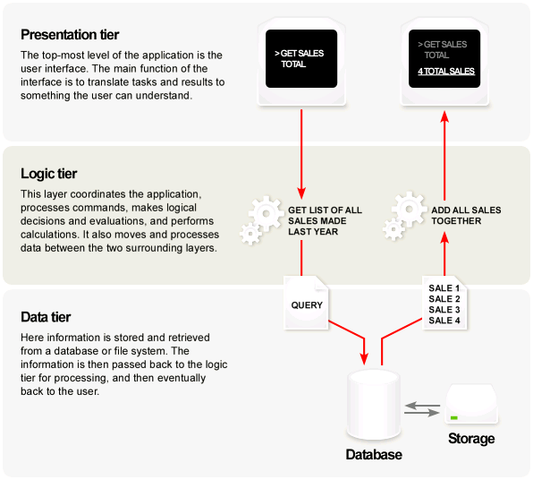
Figure 5 – Design Pattern

5.1 Client

This part includes the description, design class diagram and sequence diagram of the Client Package.

5.1.1 Description of Client Package

“Client” package’s purposes are synchronizing files within drives, PDAs and computers, which are found in the same network; logging the synchronization processes, sending files to the selected user and receiving files from the selected user over Internet.

In “Client” package, there are seven classes. The “Client” class is responsible for selecting folders to be synchronized and logging in to the Online Synchronization system.

“Sync” class is responsible for synchronizing two folders, taking a back up of a selected folder and canceling synchronization process.

“OnlineSync” class is responsible for sending and receiving files to/from the shared folder that is created for the user and his/her friend and located in the server. “OnlineSync” class sends and receives files from the server in an encrypted format Encryption and decryption processes are done in “encryptFile” and “decryptFile” functions respectively. Users can create a Friend List, add and delete friends from the “FriendList” class of the package.

“ConnecttoDatabase” class is responsible for creating connection between client computer and the file server. This class gets the friend list of the user from the server.

“PDA” class of the package is responsible for synchronizing PDA and a PC. “PDA” class can cancel synchronization process.

In this package, also a logging class is available. Using “Log” class, software keeps a log table of User’s all synchronization history. This table includes the log date, time and also the locations of the synchronized folders.

5.1.2 Design Class Diagram

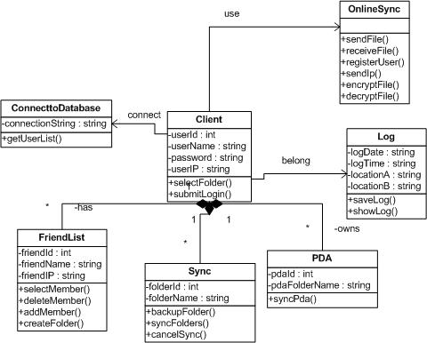

Figure 6 – Design Class Diagram of Client Package

5.1.3 Sequence Diagram(s)

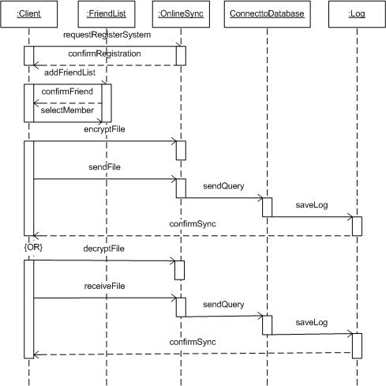

Figure 7 – Sequence Diagram of the Client Package

5.2 Server

This part includes the description, design class diagram and sequence diagram of the Server Package.

5.2.1 Description of Server Package

User’s sent and received files will be kept in the Server. Server Package will do sending and receiving operations by “sendFile” and “receiveFile” functions respectively. The files will be kept in an encrypted format in the shared folders of the users. “Folder” class of the Server Package creates the shared folders by “createFolder” function. “DeleteFunction” function deletes the selected folders.

“ConnecttoDatabase” class makes the connections between the SQL server of the FSBT and the Server Package.

“Log” class of the Server will keep log history of the synchronized folders and files. Log table includes a log date, time and the locations of the synchronized folders.

5.2.2 Design Class Diagram

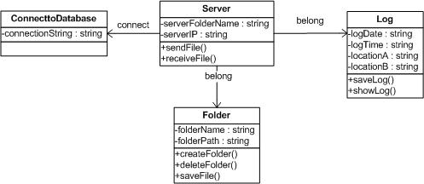

Figure 8 – Design Class Diagram of the Server Package

5.2.3 Sequence Diagram

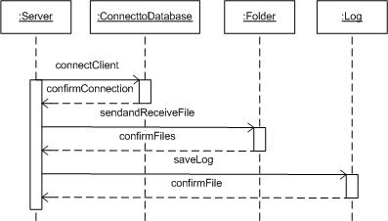

Figure 9 – Sequence Diagram of the Server Package

6. Traceability Matrix

A traceability matrix is a table that correlates any two baselined documents that require a many to many relationship to determine the completeness of the relationship.

This traceability is required to ensure that all requirements are addressed, and that only what are required is developed. The traceability matrix assures that every requirement has been addressed in the design and every design element addresses a requirement. At the table below show the relationships between design elements and the requirements.

Design Component(s):

1 | Client
2 | Server
Table 2 – Design Components

SRS Requirement | Design Component
SRS Requirement | 1 | 2
Drive to Drive Synchronization | *
PC to PC Synchronization over network | * | *
PC to PDA Synchronization | *
PC to PC Synchronization over internet | *
Backup System | *

Table 3 – Traceability Matrix

