Software Requirements Specification

File Synchronization and Backup Tool
v1.1

Acquirer : CTIS
Prepared By : Ege Ilıcak
Cenk Akın
Murat Çınar

Serkan Akşit
Date of Issue : 03 November 2008

Change History

Project Name | Version | Person Responsible | Date | Changes
File Synchronization and Backup Tool | 1.0 | Ege Ilıcak | 03-11-2008 | Initial Release
File Synchronization and Backup Tool | 1.1 | Serkan Akşit | 18-04-2009 | Changes in system features and non-functional requirements

TABLE OF CONTENTS

List of Figures 4
List of Tables 5
1 Introduction 6
1.1 Purpose 6
1.2 Scope 6
1.3 References 6
1.4 Definitions and Acronyms 7
2 Overall Description 8
2.1 Functional Requirements 8
Use Case Diagrams 8
System Features 9
Use Case Descriptions 9
2.2 Non-Functional Requirements 16
3 System Models 18
3.1 Activity Diagram 18
3.2 System Sequence Diagram 23
3.3 User Interface Mock-up Screens 26
3.4 Analysis Object Model 27

List of Figures
Figure 1 – Synchronization System Use Case 8
Figure 2 – Drive-to-Drive Synchronization Activity Diagram 18
Figure 3 – PC-to-PC Synchronization over Network Activity Diagram 19
Figure 4 – PC-to-PC Synchronization via Internet Activity Diagram 20
Figure 5 – PC-to-PDA Synchronization Activity Diagram 21
Figure 6 – Backup System Activity Diagram 22
Figure 7 – Backup System System Sequence Diagram 23
Figure 8 – Drive-to-Drive Synchronization System Sequence Diagram 23
Figure 9 – PC-to-PC over Network System Sequence Diagram 24
Figure 10 – PC-to-PDA Synchronization System Sequence Diagram 24
Figure 11 – PC-to-PC Synchronization via Internet System Sequence Diagram 25
Figure 12 – File Synchronization and Backup Tool Mock-up Screen 26
Figure 13 – Drive-to-Drive Synchronization Mock-up Screen 26
Figure 14 – PC-to-PC Synchronization via Internet Mock-up Screen 27
Figure 15 – Analysis Object Model 27

List of Tables
Table 1 - Definitions 7
Table 2 - Drive to Drive Synchronization Use Case Description 10
Table 3 - PC to PC Synchronization over network Use Case Description 11
Table 4 - PC to PDA Synchronization Use Case Description 12
Table 5 - PC to PDA Synchronization Use Case Description 15
Table 6 - Backup System Use Case Description 16

1 Introduction
This section includes purpose, scope, references and definitions for the project.

1.1 Purpose
There is a need to write an SRS document to improve the software development quality of the project. A Software Requirements Specification (SRS) is a complete description of the behavior of the system to be developed. It includes a set of use cases that describe all of the interactions that the users will have with the software. Use cases are also known as functional requirements. In addition to use cases, the SRS also contains nonfunctional (or supplementary) requirements. Non-functional requirements are requirements, which impose constraints on the design or implementation. SRS improves the quality of the process and decrease the complexity of the project development process.

This SRS document covers the requirements of the File Synchronization and Backup Tool. It includes the use-cases, which is a type of behavioral diagram defined by the Unified Modeling Language (UML); activity diagrams, which represents the operational step-by-step workflows of components in a system; sequence diagrams which shows, as parallel vertical lines, different processes or objects that live simultaneously and, as horizontal arrows, the messages exchanged between them, in the order in which they occur; non-functional requirements which specifies criteria that can be used to judge the operation of a system, rather than specific behaviors; and mock-up screens which gives a brief look of the graphical user interface of the product.

The intended audiences of the SRS are developers, project manager, users, testers, documentation writers and the project consultant.

1.2 Scope
The scope of this project is synchronizing files from drive-to-drive, PC-to-PC both on a local area network connection and over a TCP/IP connection. Also, synchronizing files between a PC and a PDA device, which has Windows Mobile 5.0, Windows Mobile 6.0 or Windows Mobile 6.1 Operating Systems using the USB port.

1.3 References
- Answers.com - http://www.answers.com/
- Answers.com - http://www.answers.com/topic/non-functional-requirements
- Answers.com - http://www.answers.com/topic/sequence-diagram
- Answers.com - http://www.answers.com/topic/activity-diagram
- Answers.com - http://www.answers.com/topic/use-case-diagram
- Answers.com - http://www.answers.com/topic/software-requirements-specification

1.4 Definitions and Acronyms
CTIS : | Computer Technology and Information Systems
IEEE : | Institute of Electrical and Electronics Engineers
FSBT : | File Synchronization and Backup Tool
MCF : | Microsoft Compact Framework
MSF : | Microsoft Sync Framework
WMBL : | Windows Mobile
DB : | Database
SYNC : | Synchronization
PL : | Programming language of the system
SDD : | Software Design Document
SRS : | Software Requirements Specification
SPMP : | Software Project Management Plan
Table 1 - Definitions

2 Overall Description
In this section, functional and non-functional requirements are determined and explained in detail.

2.1 Functional Requirements

Use Case Diagrams

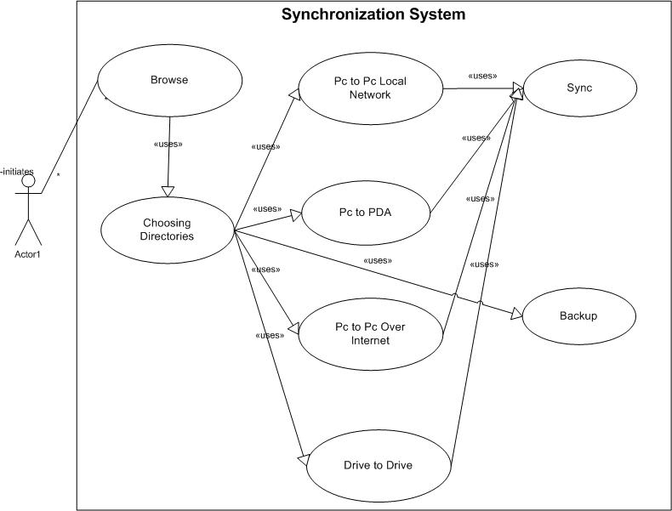
Figure 1 – Synchronization System Use Case

System Features

The features of the FSBT system are:

- Synchronizing drive to drive on the same PC.
  - User can synchronize two folders in the same PC.
  - The system will create log files to keep the track of the synchronization.
- Synchronizing folders in a Local Area Network (LAN).
  - User can synchronize two folders in the same local area network.
  - The system will create log files to keep the track of the synchronization.
- Synchronizing folders between PC and PDA device.
  - User can synchronize two folders between a PC and a PDA.
  - The system will create log files to keep the track of the synchronization.
- Synchronizing folders between two PCs over Internet.
  - User can synchronize two folders between two PCs using TCP/IP connection and the file server which will be provided by the project team.
  - User can synchronize two folders between two PCs using TCP/IP connection even the other user is offline.
  - User can select the other user to synchronize from the friend list.
  - User can add other users to the friend list.
  - The system will create log files to keep the track of the synchronization.
- Taking backup of a folder on a PC.
  - User can take backup of a folder in a PC.
  - The system will create log files to keep the track of the synchronization.
- Scheduling a synchronization process to be done in the future.
  - User can schedule a synchronization to be done at a specific time (any day of the week and any hour).
  - User can schedule a synchronization to be done in specified intervals.
- Backward Synchronization.
  - User is able to take back the latest started synchronization.
- Keeping history of synchronization.
  - The system will create log files to keep the track of the synchronization.

Use Case Descriptions

Use Case Name: | Drive to Drive Synchronization
Use Case ID: | FSBT-1
Use Case Type: | System Analysis
Primary System Actor: | PcUser
Other Participating Actors: | -
Description: | This use case describes the synchronization between two folders in the same PC. User chooses two folders from the PC. And then the algorithm of the software detects the differences between two selected folders and copies all of the different files to each other.
Precondition: | -
Trigger: | This use case is initiated when the member selects the option to synchronize drive to drive.
Typical Course of Events: | Actor Action | System Response
Typical Course of Events: | Step 1: PcUser selects the type of synchronization from the user interface.  Step 3: PcUser selects two folders from his own PC to synchronize.  Step 5: As synchronization is started, software will be synchronizing two folders. If cancel button is pressed, the process will be terminated. | Step 2: Menu of drive-to-drive synchronization will be opened.  Step 4: System determines one of the folders as source folder and the other folder as destination folder. Then, system saves metadata file to each folder.  Step 6: System compares folders and finds each difference between them and copies the different files to each folder. Then, the system keeps a log of the whole process at the database. If user clicks cancel button, the process will be terminated.
Alternate Courses: | Alt Step 5: If user selects a folder that does not have a permission to write, the system will abort the synchronization process and display an error message.
Post Condition: | The files have been synchronized and if the files do not exist will be copied.
Implementation Constraints and Specifications: | -
Table 2 - Drive to Drive Synchronization Use Case Description

Use Case Name: | PC to PC Synchronization over network
Use Case ID: | FSBT-2
Use Case Type: | System Analysis
Primary System Actor: | ActiveUser
Other Participating Actors: | OtherUser
Description: | This use case describes the synchronization of two users’ folders within a local network. User chooses two different folders from two different PCs in the local network. Then the algorithm of the software detects the differences between two selected folders and transfers all of the different folders and files between the PCs.
Precondition: | At least two PCs should be connected in the same local area network.
Trigger: | This use case is initiated when the member selects the option to synchronize PC-to-PC over network.
Typical Course of Events: | Actor Action | System Response
Typical Course of Events: | Step 1: ActiveUser selects the type of synchronization from the user interface.  Step 3: ActiveUser selects two folders, one folder from his own PC and another folder from OtherUser’s PC on local network.  Step 5: As synchronization is started, software will be synchronizing two folders from two different PCs. If cancel button is pressed or any of the computers are disconnected, the process is terminated. | Step 2: Menu of PC-to-PC Synchronization will be opened.  Step 4: System determines one of the folders as Source folder and the other folder as destination folder and system saves metadata file to each folder.  Step 6: System compares folders and finds each difference between them and copies the different files to each folder. Then, the system keeps a log of the whole process at the database. If user clicks cancel button, the process will be terminated.
Alternate Courses: | Alt. Step 5: If user selects a folder that does not have a permission to write, the system will abort the synchronization process and display an error message.
Post Condition: | The files have been synchronized and if the files do not exist will be copied.
Implementation Constraints and Specifications: | There must be at least one folder shared to the local area network.
Table 3 - PC to PC Synchronization over network Use Case Description

Use Case Name: | PC to PDA Synchronization
Use Case ID: | FSBT-3
Use Case Type: | System Analysis
Primary System Actor: | PC User
Other Participating Actors: | PDA User
Description: | This use case describes the synchronization of a user’s PC and PDA device. User chooses one folder from the PC and another folder from the PDA device. Then the algorithm of the software detects the differences between two selected folders and copies all of the differences to each folder.
Precondition: | PDA must be connected through a proper USB port.
Trigger: | This use case is initiated when the member selects the option to synchronize PC to PDA.
Typical Course of Events: | Actor Action | System Response
Typical Course of Events: | Step1: User selects the type of synchronization from the user interface.  Step3: User selects two folders, one folder from the PC and another folder from the PDA.  Step5: As synchronization is started, software will be synchronizing two folders, one folder from PC and another folder from PDA. If cancel button is pressed or any of the computers are disconnected, the process is stopped. | Step 2: Menu of PC to PDA Synchronization will be opened.  Step 4: System determines one of the folders as source folder and the other folder as destination folder and system saves metadata file to each folder.  Step 6: System compares folders and finds each difference between them and copies the different files to each folder. Then, the system keeps a log of the whole process at the database. If user clicks cancel button, the process will be terminated.
Alternate Courses: | Alt Step 5: If user selects a folder that does not have a permission to write, the system will abort the synchronization process and display an error message.
Post Condition: | The files have been synchronized and if the files do not exist will be copied.
Implementation Constraints and Specifications: | PDA device must have Windows Mobile 5.0 or higher.
Table 4 - PC to PDA Synchronization Use Case Description

Use Case Name: | PC to PC Synchronization over internet
Use Case ID: | FSBT-4
Use Case Type: | System Analysis
Primary System Actor: | PcUser1, PcUser2
Other Participating Actors: | PC
Description: | This use case explains how the algorithm of the PC to PC over internet function works in detail. First of all, a user selects the PC-to-PC SYNC over Internet. Then user logins to the system by entering username and password. And then database will bring the friend list to the user and user selects one of the friends available. Later the shared folder between user and the friend, which was chosen, has downloaded to the pc site and user makes changes as he/she wants and clicks on the Upload button and system will send the last status of the shared folder to the server site. At last, the SYNC process will be applied for the friend’s site.
Precondition: | An internet connection should be established correctly before trying to connect a computer via internet. At least one friend must be added to the friend list of the user before trying to SYNC over internet.
Trigger: | This use case is initiated when the member selects the option to synchronize PC to PC over Internet.

Typical Course of Events: | Actor Action | System Response
Typical Course of Events: | Step1: PcUser1 selects the type of synchronization from the user interface.  Step3: PcUser1 opens up the Login panel. If user is a member of the system, enters nickname and password, if not, user signs up.  Step5: PcUser1 saw the main screen of the system.  Step7: PcUser1 adds friends to the Friend list.  Step9: PcUser1 selects PcUser2 from the Friend list and clicks to the ‘update shared folder’ button and sends the request to the server.  Step11: If user adds any files to the shared folder and wants to send to PcUser2; he sends the shared folder to the server by clicking the “synchronize” button. | Step 2: Menu of PC-to-PC online Synchronization will be opened.  Step4: System checks nickname and password from database. If user is not a member, system saves username and password that was written in sign up panel and also adds an entry to the database for his membership.  Step6: Database sends the Friend list to the PcUser1.  Step8: Verification prompt will be sent to the friends that PcUser1 added to the Friend list and a shared folder is created between each friend.  Step10: Server sends the shared folder that exists between PcUser1 and PcUser2 to the PcUser1. The folder that was downloaded from the server will be copied to the shared folder, which was created between PcUser1 and PcUser2, on the PcUser1’s side.
Alternate Courses: | Alt Step 4: If internet connection is not available or having a high latency, the software will not be able to establish connection between the PC and the web server. As a result, the process will be terminated and a warning message will be displayed.
Post Condition: | A proper internet connection must be established before trying to SYNC over internet.
Implementation Constraints and Specifications: | -
Table 5 - PC to PDA Synchronization Use Case Description

Use Case Name: | Backup System
Use Case ID: | FSBT-5
Use Case Type: | System Analysis
Primary System Actor: | PcUser
Other Participating Actors: | -
Description: | This use case describes the backup process of a user’s folder. User chooses two folders from the PC. Then the algorithm of the software detects the differences between two selected folders and copies all of the differences to each folder.
Precondition: | -
Trigger: | This use case is initiated when the member selects the option to synchronize drive-to-drive.
Typical Course of Events: | Actor Action | System Response
Typical Course of Events: | Step 1: PcUser selects the type of synchronization from the user interface.  Step 3: PcUser selects two folders from his own PC to get backup.  Step 5: As synchronization is started, software will be synchronizing two folders. If cancel button is pressed, the process will be terminated. | Step 2: Menu of Drive-to-Drive Synchronization will be opened.  Step 4: System determines one of the folders as source folder and the other folder as destination folder and system saves metadata file to each folder.  Step 6: System compares folders and finds each difference between them and copies the different files to each folder. Then, the system keeps a log of the whole process at the database. If user clicks cancel button, the process will be terminated.
Alternate Courses: | Alt Step 5: If user selects a folder that does not have a permission to write, the system will abort the synchronization process and display an error message.
Post Condition: | The files are backed up.
Implementation Constraints and Specifications: | -
Table 6 - Backup System Use Case Description

2.2 Non-Functional Requirements
Category | Nonfunctional requirements
Usability | - Users must be able to access the files to synchronize.  - The drives that are being used for the synchronization process must be recognized by the operating system.  - PDA must have a USB or a Mini-USB port to establish connection with a PC.  - The PC must have at least one USB port, a CD-ROM Drive that has at least 4x speed or Ethernet connection.  - 32-bit Windows XP or higher operating systems are supported.  - Any mobile phone or PDA, that is recognized as a removable storage by the operating system is supported unless the files are encrypted and the required privileges are given to the user.  - A broadband Internet connection is strictly required to perform a PC-to-PC synchronization over TCP/IP connection where a file server will be up and running for online synchronization between two users.  - In a Windows XP or higher operating system, Windows firewall strictness level must be set to off.  - In a PC-to-PC synchronization on a local area network, both users’ PC must be operating at the same time.  - In a PC-to-PC synchronization on a local area network, any one of two PCs must have at least one shared folder open to the local network.
Reliability | - Crashes caused in PC-to-PC synchronization over TCP/IP connection, only the users’ doing the synchronization will be disconnected but the file server will be up.
Performance | - A 1.7 GHz CPU, 100 MB HDD and 512 MB RAM PC is recommended for an optimized quality of usage.  - File Server must be able to synchronize up to 50 users’ files.
Supportability | - VB.NET naming conventions will be used.
Implementation | - File extension options must be at same value for both PCs.  - .NET Framework 2.0 and 3.5 must be installed.  - Microsoft Sync Framework 1.0 must be installed.
Operation | - User should not be able to login after 3 tries.
Legal | - User privileges must be set at required level for setup and usage.  - Network Sharing must be turned on for PC-to-PC Synchronization in a Local Area Network.  - For 32-bit Windows Vista, Network Discovery mode must be activated for PC-to-PC Synchronization in a Local Area Network.

3 System Models
In this section; Activity Diagram (for complex workflows), System Sequence Diagram, User Interface mock-up screens and Analysis Object Model will be contained and explained.

3.1 Activity Diagram
This section shows the activity diagrams of the FSBT.

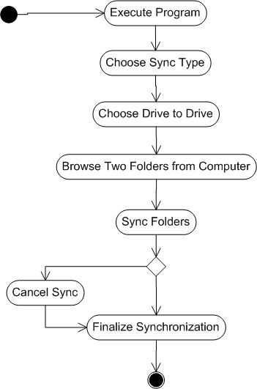
Figure 2 – Drive-to-Drive Synchronization Activity Diagram
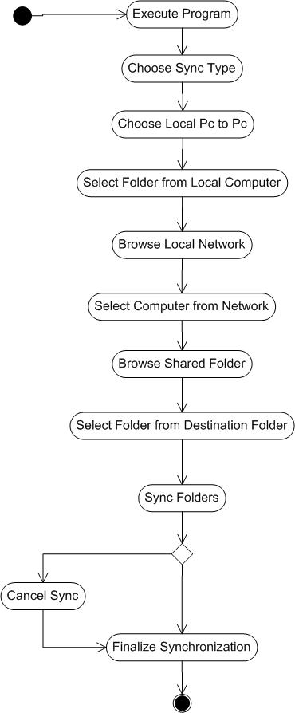
Figure 3 – PC-to-PC Synchronization over Network Activity Diagram
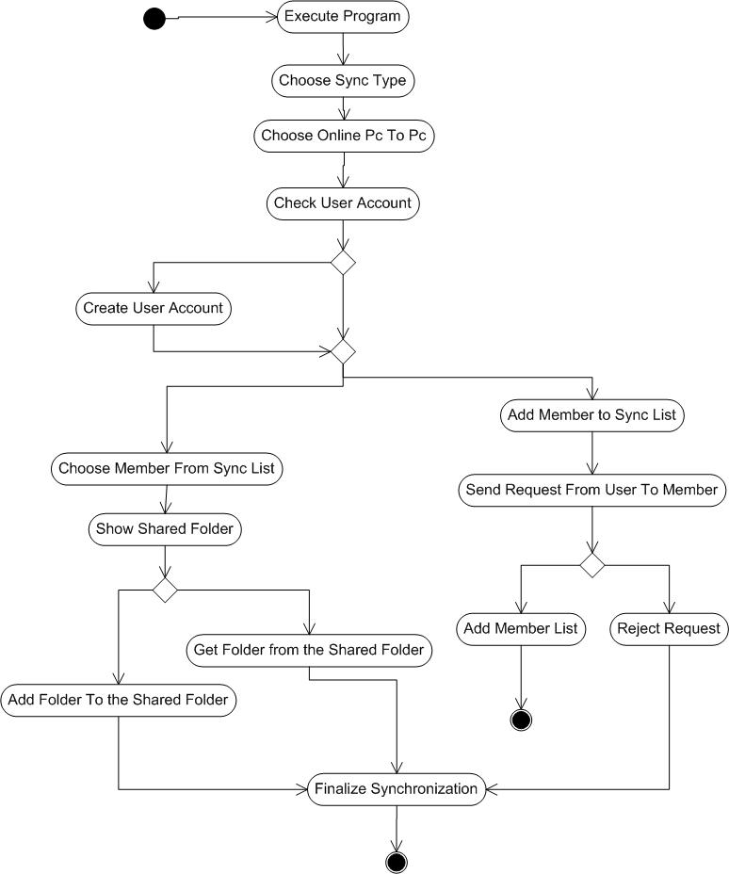
Figure 4 – PC-to-PC Synchronization via Internet Activity Diagram
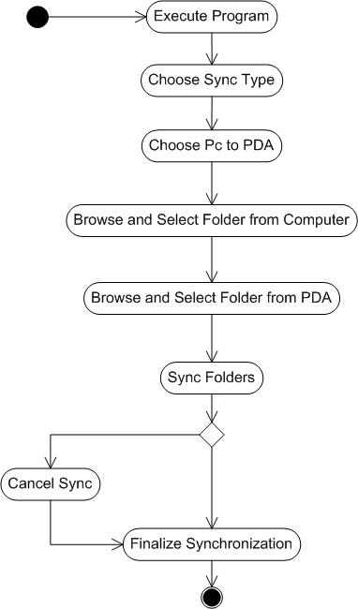
Figure 5 – PC-to-PDA Synchronization Activity Diagram
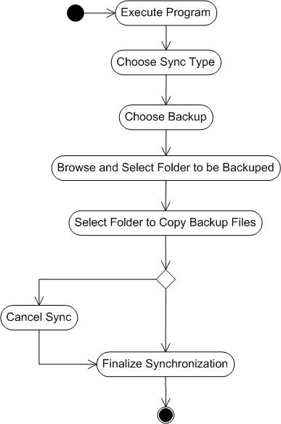
Figure 6 – Backup System Activity Diagram

3.2 System Sequence Diagram
This section shows the System Sequence Diagrams of the FSBT.

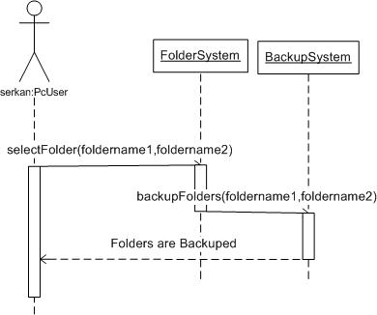

Figure 7 – Backup System System Sequence Diagram

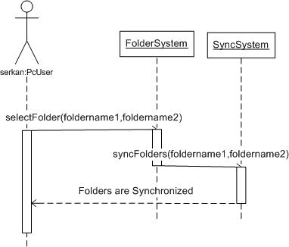
Figure 8 – Drive-to-Drive Synchronization System Sequence Diagram
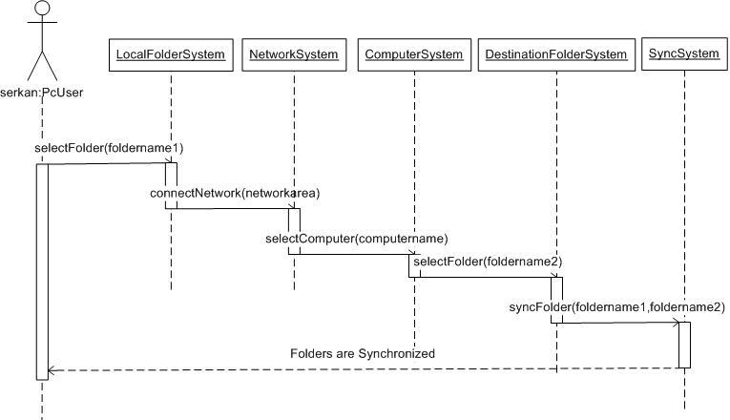
Figure 9 – PC-to-PC over Network System Sequence Diagram

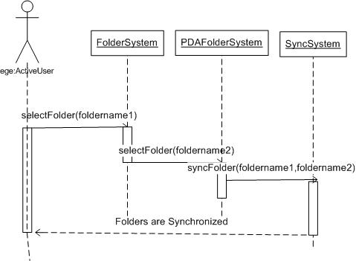
Figure 10 – PC-to-PDA Synchronization System Sequence Diagram

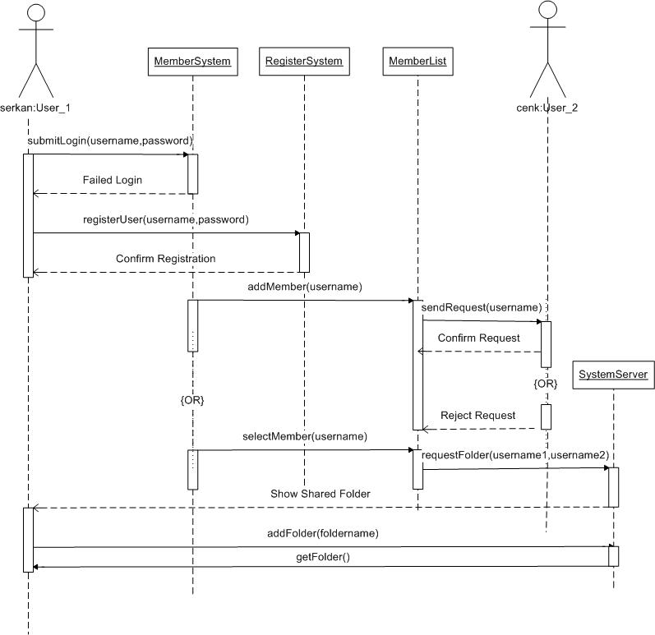
Figure 11 – PC-to-PC Synchronization via Internet System Sequence Diagram

3.3 User Interface Mock-up Screens
This section contains mock-up screens for the FSBT.

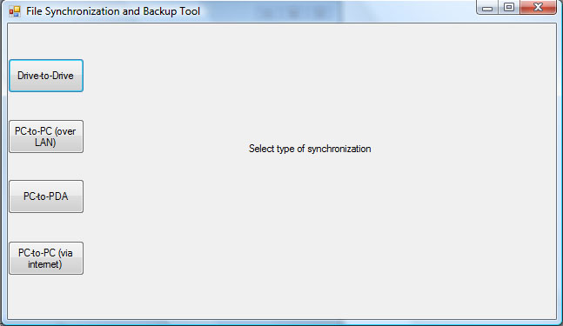
Figure 12 – File Synchronization and Backup Tool Mock-up Screen

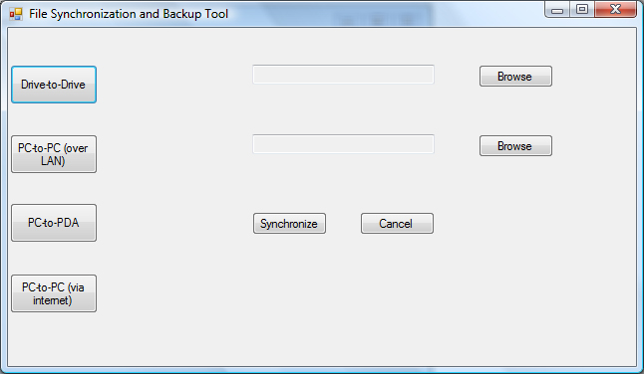
Figure 13 – Drive-to-Drive Synchronization Mock-up Screen

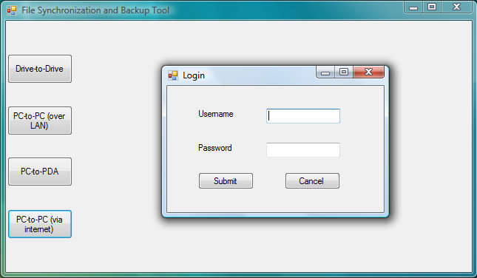
Figure 14 – PC-to-PC Synchronization via Internet Mock-up Screen

3.4 Analysis Object Model
This section shows the Analysis Object Model for the FSBT.
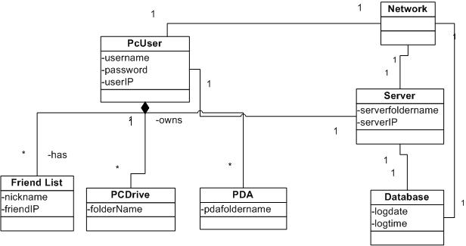
Figure 15 – Analysis Object Model

