SOFTWARE REQUIREMENTS SPECIFICATION
FOR
WEB-BASED TRACKING SYSTEM FOR CTIS ALUMNI
(Team – 19)

Acquirer : Ayşin Solak ÖRKÇÜOĞLU
Team Members : Bengü KARAKOÇ
Bora KORKMAZ
Burçak AYDIN
Gizem SELEK
Revision : 1.0

Due Date : November 03, 2008

Signatures:

_________________________
Bengü KARAKOÇ – Group Manager

_________________________
Bora KORKMAZ – Group Member

_________________________
Burçak AYDIN – Group Member

_________________________
Gizem SELEK – Group Member

_________________________ __________________________
Beyhan Akporay Ayşın Solak ÖRKÇÜOĞLU
Senior Project Manager Project Consultant
Change History

Date | Version | File Name | Document Format | Status
03/11/2008 | 1.0 | Team19_SRS_v1.0en.doc | MS Word | Created

Table Of Contents
1 Introduction 5
1.1 Purpose 5
1.2 Scope 6
1.3 References 7
1.3.1 Book, Documents 7
1.3.2 Web References 7
1.4 Definition and Acronyms and Abbreviations 7
2 Overall Description 8
2.1 Functional Requirements 9
2.1.1 Use Case Model/Context Diagram 9
2.1.2 The major system features 11
2.1.3 Use Case Descriptions 12
2.2 Non-Functional Requirements 29
2.2.1 Reliability 29
2.2.2 Availability 29
2.2.3 Maintainability 29
2.2.4 Security 29
2.2.5 Accessibility 30
2.2.6 Portability 30
3 System Model 30
3.1 Activity Diagram 30
3.1.1 Alumni Add Photo 31
3.1.2 Alumni Enter the System 33
3.1.3 Alumni Manage Own Profile 34
3.1.4 Alumni Request Announcement 35
3.1.5 Alumni Search User 36
3.1.6 Admin Create User 37
3.1.7 Admin Manage Language Filter 38
3.1.8 Admin User Info 39
3.1.9 Admin Manage Announcements 40
3.1.10 Admin Sends Mass Mail 41
3.1.11 Admin Search Alumni 42
3.1.12 Admin Modify Status 43
3.1.13 Admin Manage User Account 44
3.2 System Sequence Diagram 45
3.2.1 Manage User Account Sequence 45
3.2.2 Search User Sequence 46
3.3 User Interface mock-up screens 47
3.4 Analysis Object Model 50

Preface

This document is the Software Requirements Specification of Web-based Tracking System for CTIS Alumni. The WTS system is web-based tracking system that will allow keeping information CTIS students after their graduation and the department can reach their alumnus information’s. The main aim of this system that creating connection between CTIS alumnus and departments. And also system will allowed to alumnus following news about their old friends and department or sending e-mail by administrator who should be control or authorized.
This document, which name is software requirements specification, is prepared by according to IEEE STD 1058-1998, IEEE Recommended Practice for Software Requirements Specification. This document involve understanding the functions and constraints in terms of product’s specification and also understanding the relationship with goals about it.Applying the following stages for this document will be helped to evaluate the success of the project.

Introduction

Purpose

The purpose of software requirements specification document is identifying the product. It is the most important fact that SRS contain functional and non-functional requirements.
In addition, SRS is often referred as “parent” document because all of the following documents such as design specifications, representing of work, specification architecture, verification and validation, testing and also documentation plans. Also those attribute of a system including performance, reliability, security, maintainability, availability, safety requirements and design constraints. If project’s functionality will be defined using all the attributes, it will conserve of ambiguity.This document is written by natural language to prevent misunderstanding between the client and the developer team.This document provides comprehensive contract between CTIS department and developers.

Scope

The aim of the Web-based Tracking System is to create an account for individuals CTIS Alumnus to provide connection between alumnus and CTIS department. The project has two different type of interface; one of them is seemed by the admin and the other one is seemed by the alumni so alumni and admin has special privileges for their account.
The software product shall allow the admin to;
- Manage and delete alumni members.
- Create an alumni account.
- Send e-mail to one or more alumni members.
- Modify site status.
- Publish their announcements.
- Edit and delete the announcements.
- Manage language filter.
- See the class news.
- Search an alumni member.
- Update information.
The software product shall allow the alumni to;
- View alumnus according to year.
- Search alumnus according the given fields.
- View class news.
- Send e-mail to one or more alumni members.
- Update information.

References

Book, Documents

[1] Craig Larman, Applying UML and Patterns, an Introduction to Object-Oriented Analysis and Design and the Unified Process, Second Edition, Pearson Prentice Hall, 2002
[2] IEEE Computer Society, Guide to the Software Engineering
Body of Knowledge, 2004 version

Web References

[3] Computer Technology and Information System Alumni (n.d.). , from http://139.179.33.221/alumni/

Definition and Acronyms and Abbreviations

Acquirer: Ayşin Solak Örkçüoğlu is the acquirer of this project. She determines and modifies the requirements of the project. In addition, Ayşin Solak Örkçüoğlu accepts software product and its documentation.

.NET Framework: The Microsoft .NET Framework is a software technical methods which is practicable with few Microsoft Windows operating systems.

WBTSCA: | Web-Based Tracking System for CTIS Alumni
WTS: | Web-Based Tracking System
CTIS: | Computer Technology and Information System
MySQL: | Database Management Systems
SRS: | Software Requirements Specification
SPMP: | Software Project Management Plan
SDD: | Software Design Document
COCOMO: | Constructive Cost Model
IS: | Information Systems
C# .NET: | A Computer Language
HTTP: | Hyper Text Transfer Protocol
SPMP: | Software Project Management Plan
DB: | Database
SA: | Systems Administrator
AA: | Actor Action
SR: | System Response
SW: | Software
HW: | Hardware

Table 1 – Abbreviations

Overall Description

This part of the project describes the aim, scope and the functions of the project. And also it shows the requirements of the WTS system. The WTS system for CTIS alumni, shows the information from the Alumni Database, from the department system. This system will be completely web-based and any user can connect to the system using a standard web browser.

Functional Requirements
Functional requirements include system software’s specific functions, tasks or behaviours the system must support.

Use Case Model/Context Diagram

Figure1-Use Case Model/Context Diagram for Admin

Figure2-Use Case Model/Context Diagram for Alumni

The major system features
Administrator(s) of the system shall:
- Sign in to the system
- Log out from the system
- Create account for user(s)
- Search one or more user
- Write announcements
- Confirm and publish announcements sent by user(s)
- Delete user(s)
- Manage information about user(s)
- Send e-mail to one or more user(s)
- Update site status
- Modify language filter

Users of the system shall:
- Sign in to the system
- Log out from the system
- Manage contact information
- Search other user(s) information
- View announcement(s)
- Send announcement(s) request(s)
- Change password
- Send e-mail to admin

Use Case Descriptions

Use Case Name | Create User Account
Use Case ID | WTS-UCAD001
Use Case Type | System Analysis
Primary System Actor | System Administrator(Active Member)
Participating Actors | - Database Management System  - Accounts Receivable(External server)
Description | This use case describes;  - How the administrator adds a new member to the system,  - How the system determines the username and the password.
Precondition | - User must be logged in to the system.
Trigger | User clicks the Create User Account link.
Typical Course of Events
  Actor Action | System Response
  Step 1: User enters the first name, surname, e-mail, graduation year and selects the user role. | Step 2: System creates a user name and a password for the new account.  Step 3: System checks the given information if it already exists in the system.  Step 4: The newly entered information stored in the system.  Step 5: System sends an e-mail to the new user that contains new user name and password.  Step 6: Validation message displayed on the screen.  Step 7: “Add New Member” page displayed.
Alternate Courses | An error may occur in Database actions.  Error message displayed on the screen.  Alt-Step 3: Information entered could be the same of one of the records in the Sytem.  Error message displayed on the screen.  System asks the user for confirmation of the user create.
Post-Conditions | -
Implementation Constraints and Specifications | - Server must be in an active condition.  - Site status must be online.

Table 1. Use Case of Create User Account

Use Case Name | Manage News
Use Case ID | WTS-UCAD002
Use Case Type | System Analysis
Primary System Actor | System Administrator(Active Member)
Participating Actors | - Database Management System  - Accounts Receivable(External server)
Description | This use case explains;  - how the user adds news to the system,  - how the user deletes an existing news from the system,  - how the user edits an existing news from the system.
Precondition | - User must be logged in to the system.
Trigger | User clicks the Class News Button.
Typical Course of Events
  Actor Action | System Response
  Step 2: User clicks the “Add Announcement“ button.  Step 4: User clicks the “read more” link.  Step 6: User clicks the “Delete” button. | Step 1: “Display News” screen appears on the screen.  Step 3: Invoke abstract Use Case WTS-AUCAD001. Adds a new announcement to the system.  Step 5: Invoke abstract Use Case WTS-AUCAD002. Edits an existing announcement.  Step 7: Invoke abstract Use Case WTS-AUCAD003. Deletes an existing announcement.
Alternate Courses | An error may occur in Database actions.  Error message displayed on the screen.
Post-Conditions | -
Implementation Constraints and Specifications | - Server must be in an active condition.  - Site status must be online.

Table 2. Use Case of Manage News

Use Case Name | Find Alumni
Use Case ID | WTS-UCAD003
Use Case Type | System Analysis
Primary System Actor | System Administrator(Active Member)
Participating Actors | - Database Management System  - Accounts Receivable(External server)
Description | This use case shows;  - How the user searches one or more alumni members and their individual information for the given criterias,  - How the user sends e-mail to one or more alumni members for the given criterias.  - How the user sends mass mails.
Precondition | - User must be logged in to the system.
Trigger | User clicks the “Find Alumni” link.
Typical Course of Events
  Actor Action | System Response
  Step 1: User enters information, according to the search criteria into the textfields.  Step 2: User clicks the “Search User” button.  Step 4 : User selects the fields to be displayed .  Step 6: User clicks to the checkboxes to choose who to send e-mails.  Step 7: User clicks the “Send Mail” link.  Step 9: User enters the e-mail body and/or mail subject.  Step 10: User attaches a file if necessary.  Step 11: User clicks the send e-mail button. | Step 3: The selected fields of the Alumni members for the given criteria appears on the screen in a table.  Step 5: Alumni’s information pop-up screen appears.  Step 8: “Send Mail” page appears.  Step 12: Language filter checks the mail to prevent the bad words.  Step 13: System sends the e-mails to the selected alumni members.  Step 14: A validation message appears on the screen.  Step 17: An excel file appears on the bottom of the screen which stores the alumnus’ information that is checked by user.
Alternate Courses | An error may occur in Database actions.  Error message displayed on the screen.  Alt-Step 11: If Language filter finds any banned words.  Go to Step 9 in Typical Course of Events.
Post-Conditions | -
Implementation Constraints and Specifications | - Server must be in an active condition.  - Site status must be online.

Table 3. Use Case of Find Alumni

Use Case Name | Manage User Account
Use Case ID | WTS-UCAD005
Use Case Type | System Analysis
Primary System Actor | System Administrator(Active Member)
Participating Actors | - Database Management System  - Accounts Receivable(External server)
Description | This use case shows;  - How the user views the alumni members for the given criterias,  - How the user deactivates and activates an alumni member’s account,  - How the user updates alumni members’ information,  - How the user deletes an existing alumni member.
Precondition | - User must be logged in to the system.
Trigger | User clicks the Manage User link.
Typical Course of Events
  Actor Action | System Response
  Step 1: User enters the First Name and Last Name of the system member to the fields.  Step 2: User selects the fields to be displayed.  Step 3: User clicks the “Search Member” button.  Step 5: User clicks the desired alumni’s Name.  Step 7: User clicks on the “De-Activate” button.  Step 11: User clicks the “Edit” link.  Step 13: User changes the desired fields.  Step 14: User clicks the “Update” button.  Step 18: User clicks the “Delete” link.  Step 20: User clicks the “OK” button. | Step 4: Corresponding results are shown in the “Manage User Account” page.  Step 6: Alumni’s information appears in a pop-up screen.  Step 8: Activation information of the user has changed on the Database system.  Step 9: A validation message appears on the screen.  Step 10: “Manage User Account” page appears on the screen.  Step 12: The selected user’s information appears on the screen.  Step 15: System stores the newly entered information.  Step 16: A confirmation message appears on the screen.  Step 17: “Manage User Account” page appears on the screen.  Step 19: A pop-up window appears.  Step 21: A confirmation message appears on the screen.  Step 22: User account has been deleted from system.  Step 23: “Manage User Account” page appears on the screen.
Alternate Courses | An error may occur in Database actions.  Error message displayed on the screen..  Alt-Step 3: User may not enter any data into the fields.  Error message displayed on the screen.  Go to Step 1 in Typical Course of Events.  Alt-Step 20: User may click the “Cancel” button instead of the “OK” button.  Return to “Manage User Account” page..
Post-Conditions | -
Implementation Constraints and Specifications | - Server must be in an active condition.  - Site status must be online.

Table 4. Use Case of Manage User Account

Use Case Name | Update User Information
Use Case ID | WTS-UCAD006
Use Case Type | System Analysis
Primary System Actor | System Administrator(Active Member)
Participating Actors | - Database Management System  - Accounts Receivable (external server)
Description | This use case describes;  - How the user updates or changes his/her individual information.
Precondition | - User must be logged in to the system.
Trigger | - This use case is initiated when the user clicks the update information links.
Typical Course of Events
  Actor Action | System Response
  Step 2: User changes the desired information.  Step 3: User clicks the “update” button. | Step 1: User information appears on screen.  Step 4: System stores the data.  Step 5: A validation message appears on the screen.  Step 6: “Admin control panel” page is displayed.
Alternate Courses | Alt Step 3: If user does not enter the required information,  Error message appears on the screen.  Go to step 2 in Typical Course of Events.  An error may occur in Database actions.  Error message appears on the screen.
Post-Conditions | -
Implementation Constraints and Specifications | - Server must be in an active condition.  - Site status must be online.

Table 5. Use Case of Update User Information

Use Case Name | Manage Language Filter
Use Case ID | WTS-UCAD007
Use Case Type | System Analysis
Primary System Actor | System Administrator (Active Member)
Participating Actors | Database Management System  Accounts Receivable (external server)
Description | This use case explains;  - How the user ban any given words in the system.
Precondition | - User must be logged in to the system.
Trigger | This use case has initiated when the user clicks the manage language filter link.
Typical Course of Events
  Actor Action | System Response
  Step 1: User adds one or more bad words or changes an existing word.  Step 2: User clicks the “save” button. | Step 3: System stores the data.  Step 4: A validation message appears on the screen.  Step 5: “Manage Language Filter” page is displayed
Alternate Courses | An error may occur in Database actions.  Error message appears on the screen.
Post-Conditions | -
Implementation Constraints and Specifications | - Server must be in an active condition.  - Site status must be online.

Table 6. Use Case of Manage Language Filter

Use Case Name | Modify Site Status
Use Case ID | WTS-UCAD008
Use Case Type | System Analysis
Primary System Actor | System Administrator (Active Member)
Participating Actors | Database Management System  Accounts Receivable (external server)
Description | This use case helps;  - The system to be protected from the outsider attacks.  - If the system is under constraction,it will be temporary unavaible to alumnus to connect the system.
Precondition | User must be logged in to the system.
Trigger | This use case has initiated when the user clicks the modify site status link.
Typical Course of Events
  Actor Action | System Response
  Step 1: User selects the site status from the combo box.  Step 2: User enters the status information.  Step 3: User clicks the “change” button. | Step 4: System stores the ststus information.  Step 5: A validation message appears on the screen.  Step 6: “Admin Control Panel” page is displayed.
Alternate Courses | An error may occur in Database actions.  Error message appears on the screen.
Post-Conditions | -
Implementation Constraints and Specifications | - Server must be in an active condition.  - Site status must be online.

Table 7. Use Case of Modify Site Status

Use Case Name | Enter the System
Use Case ID | WTS-UCAL001
Use Case Type | System Analysis
Primary System Actor | CTIS Alumni (Active Member), System Administrator
Participating Actors | DatabaseManagementSystem  Accounts Receivable (external server)
Description | This use case describes;  - How the users enters the system by using the username and the password sent by the system.  - How the user enters the system even if he/she forgets the username and password.
Precondition | User must have a valid user name and password.
Trigger | This use case initiated when the user enters the CTIS Alumni home page.
Typical Course of Events
  Actor Action | System Response
  Step 1: User enters the username and the password sended by the system.  Step 2: User clicks the login button. | Step 3: System validates the username and password.  Step 4: Alumni Home Page is displayed.
Alternate Courses | An error may occur in Database actions.  Error message appears on the screen.  Alt Step 2: Given information may be incorrect.  Error message appears on the screen.  Go to step 1 in Typical Course of Events.  Alt Step 2: User may not enter the required fields.  Error message appears on the screen.  Go to step 1 in Typical Course of Events.  User may forget the password. For that reason, the user clicks the “Forgot your password?” link.  The system sends the password to the users’ personal e-mail account.
Post-Conditions | -
Implementation Constraints and Specifications | - Server must be in an active condition.  - Site status must be online.

Table 8. Use Case of Enter the System

Use Case Name | Manage Own Profile
Use Case ID | WTS-UCAL002
Use Case Type | System Analysis
Primary System Actor | CTIS Alumni(Active Member)
Participating Actors | Database Management System  Accounts Receivable (external server)
Description | This use case describes;  - How the user changes any personal information,  - How the user deletes any personal information,  - How the user hides any personal information for the others not to see.
Precondition | User must be logged in to the system.
Trigger | This use case is initiated when the user clicks the update information link.
Typical Course of Events
  Actor Action | System Response
  Step 1: User’s information appears on the screen.  Step 2: User updates the desired information.  Step 3: User clicks the “update” button. | Step 4: System stores the new information.  Step 5: A validation message appears on the screen.  Step 6: System shows the “update information” page.
Alternate Courses | Alt Step 4: An error may occur in Database actions.  Error message appears on the screen.  Alt Step 3: If the required fields are empty,  Error message appears on the screen.  Go to step 2 in Typical Course of Events.  Alt Step 3: Entering data may be wrong or invalid.  Error message appears on the screen.  Go to step 2 in Typical Course of Events.
Post-Conditions | -
Implementation Constraints and Specifications | - Server must be in an active condition.  - Site status must be online.

Table 9. Use Case of Manage Own Profile

Use Case Name | Send Announcements
Use Case ID | WTS-UCAL003
Use Case Type | System Analysis
Primary System Actor | CTIS Alumni(Active Member)
Participating Actors | Database Management System  Accounts Receivable (external server)
Description | This use case describes;  - How the user writes an announcement and not directly publish it but to send a request to publish the announcement.
Precondition | User must be logged into the system.
Trigger | This use case is initiated when the user clicks the make announcement link.
Typical Course of Events
  Actor Action | System Response
  Step 1: User enters the desired announcement.  Step 2: User clicks the “send” button. | Step 3: Language filter checks the mail to prevent the bad words.  Step 4: A validation message appears on the screen.  Step 5: “Announcement page” appears on the screen.
Alternate Courses | Alt-Step 3: If Language filter finds bad words.  Go to step 1 in Typical Course of Events.  Alt- Step 4: If user doesn’t enter any data to the fields  Error message appears on the screen.  Go to step 3 in Typical Course of Events.
Post-Conditions | -
Implementation Constraints and Specifications | - Server must be in an active condition.  - Site status must be online.

Table 10. Use Case of Send Announcements

Use Case Name | Search User
Use Case ID | WTS-UCAL004
Use Case Type | System Analysis
Primary System Actor | CTIS Alumni(Active Member)
Participating Actors | Database Management System  Accounts Receivable (external server)
Description | This use case describes;  - How the user searches an alumni member as the given criterias,  - How the user sees personal information of the selected user,  - How the user sends an e-mail to the other alumni members.
Precondition | User must be logged into the system.
Trigger | This use case is initiated when the user clicks the “find user” button.
Typical Course of Events
  Actor Action | System Response
  Step 1: User enters the search criterias.  Step 2: User clicks the search button.  Step 4: User clicks the selected alumni’s name.  Step 6: User clicks the check boxes.  Step 7: User clicks the “send mail” button.  Step 9: User enters subject and/or mail body.  Step 10: User attaches a file if necessary.  Step 11: User clicks “send mail” button. | Step 3: Search results appear on the screen.  Step 5: Selected alumni’s personal information appears on the screen.  Step 8: “Send Mail” page appears.  Step 12: A validation message appears on the screen.  Step 13: “Search Results” page displayed.
Alternate Courses | An error may occur in Database actions.  Error message appears on the screen.  Alt Step 7: If user does not check any of the checkbox(es),  Error message appears on the screen.  Go to step 6 in Typical Course of Events.  Alt Step 11: If user does not fill the mail body,  Error message appears on the screen.  Go to step 9 in Typical Course of Events.
Post-Conditions | -
Implementation Constraints and Specifications | - Server must be in an active condition.  - Site status must be online.

Table 11. Use Case of Search User

Use Case Name | Add Photo
Use Case ID | WTS-UCAL005
Use Case Type | System Analysis
Primary System Actor | CTIS Alumni(Active Member)
Participating Actors | Database Management System  Accounts Receivable (external server)
Description | This use case explains;  - How to create an album,  - How the alumnus to add photos to the system,  - How the alumnus to see all the photos added to the system.
Precondition | User must be logged in to the system.
Trigger | User clicks the Gallery button.
Typical Course of Events
  Actor Action | System Response
  Step 2: User clicks the add album button.  Step 4: User enters the album name.  Step 5: User selects the files to upload.  Step 6: User clicks the add photos button.  Step 10: User clicks the desired album cover.  Step 17: User Clicks the desired photo. | Step 1: All of the albums and Album names are shown on the screen.  Step 3: Create Album page appears.  Step 7: System stores the photos.  Step 8: A confirmation message appears.  Step 9: “See All Albums” Page displayed.  Step 11: All of the photos belong to that album are shown as thumbnails.  Step 19: Selected photo appears on the screen as enlarged form.
Alternate Courses | Alt Step 6: User may not select any photos to add.  Error message appears on the screen.  Go to step 5 in Typical Course of Events.  An error may occur in Database actions.  Error message appears on the screen.
Post-Conditions | -
Implementation Constraints and Specifications | - Server must be in an active condition.  - Site status must be online.

Table 12. Use Case of Add Photo

Use Case Name | Adds a new announcement to the system.
Use Case ID | WTS-AUCAD001
Use Case Type | Abstract
Priority | High
Source | WTS-UCAD002
Primary System Actor | System Administrator(Active Member)
Participating Actors | Database Management System  Accounts Receivable (external server)
Description | This use case explains;  - How to add announcements to the system.
Precondition | User must be logged in to the system.
Trigger | User clicks the Add Announcement link.
Typical Course of Events | Step 1: User enters the desired announcement into the fields.  Step 2: User chooses the event date from the calendar.  Step 3: User clicks the “Add” button.  Step 4: System stores the new information entered.  Step 5: System asks the user to send the given News as mass mail.  Step 6: Select Year page appears.  Step 7: All the alumnus for the given years appears on the screen.  Step 8: The news have sended as a mass mail.  Step 9: A validation message appears on the screen.  Step 10: “Display News “page appears on the screen.
Alternate Courses | Alt-Step 2: User may not choose any event date by clicking the “No Event Date” checkbox.  Alt-Step 3: User may not be entered any information required.  Error message displayed on the screen.  Go to Step 1 in Typical Course of Events.  An error may occur in Database actions.  Error message appears on the screen.
Post-Conditions | -

Table 13. Use Case of Adds a new announcement to the system

Use Case Name | Edits an existing announcement.
Use Case ID | WTS-AUCAD002
Use Case Type | Abstract
Priority | High
Source | WTS-UCAD002
Primary System Actor | System Administrator(Active Member)
Participating Actors | Database Management System  Accounts Receivable (external server)
Description | This use case explains;  - How to edit announcements in the system.
Precondition | User must be logged in to the system.
Trigger | User clicks the “Read More” link.
Typical Course of Events | Step 1: User makes any changes in the given text if necessary.  Step 2: User clicks the save button.  Step 3: System stores the new information entered.  Step 4: A validation message appears on the screen.  Step 5: “Edit News” page appears on the screen.
Alternate Courses | An error may occur in Database actions.  Error message displayed on the screen.
Post-Conditions | -

Table 14. Use Case of Edits an existing announcement

Use Case Name | Deletes an existing announcement.
Use Case ID | WTS-AUCAD003
Use Case Type | Abstract
Priority | High
Source | WTS-UCAD002
Primary System Actor | System Administrator(Active Member)
Participating Actors | Database Management System  Accounts Receivable (external server)
Description | This use case explains;  - How to delete announcements in the system.
Precondition | User must be logged in to the system.
Trigger | User clicks the “Read More” link.
Typical Course of Events | Step 1: A pop-up window appears on the screen.  Step 2: User clicks the “OK” button.  Step 3: Selected text is deleted from the system.  Step 4: A confirmation message appears on the screen.  Step 5: “Display News” screen appears.
Alternate Courses | An error may occur in Database actions.  Error message displayed on the screen.  Alt-Step 2: User may click the “Cancel” button instead of the “OK” button.  Return to “Display News” page.
Post-Conditions | -

Table 15. Use Case of Deletes an existing announcement

Non-Functional Requirements
Non-functional requirements define the software system’s quality, properties and constraints.
A few examples of non-functional requirements are:

Reliability
Reliability is the ability of to maintain the required functions under any circumstances. If the any changes (design, functions, data etc.) will be occurred in the WTS, the testing team should test all the changes done. Implementing the process of the system will be tested and coded concurrently. Trough this application the process leads to improve the system reliability and also reliability can affect the customer’s psychological view.

Availability
For the reason, WTS is a web-based program so the connection is the most important feature of the system which has a department database and application domain. If any problem will be occurred on database or internet connection, it may lead to cause problems on the system.
The CTIS department will be responsible the control of the database server so database must be available in any circumstances and also internet connection must be available.

Maintainability
Maintainability is the process of modifying the software product and also will be upgraded according to customer requirements which are requested by customer. This process provides to satisfy customer needs, go with the new technology and changing environment. For instance, if the customers want to add new modules to the project, the acquirer and developers shall make a new agreement. As a result of this, developers will be modified the whole system according to new agreement. Besides, the projects maintainability should be easily integrated changes in new modules and new technological solutions for the system.

Security

WTS is an internet application so there may be many attacks to the system. Admin have many privileges to prevent these attacks. For instance, admin can change site status against these attacks. In addition, if alumnus do not want to show their individual information, they will hide those information and the hidden fields can not be seen by the other alumnus.

Accessibility
Only admin can access and change all the alumnus individual information.

Portability
This software project is a web-based application so any hardware installation is not necessary. The user enters this software product’s web site in any computer in other words; typing the internet address to the address bar will be enough.

System Model

The analyst of the system uses system modeling to make the communication with customer more efficient and reliable.

Activity Diagram
Activity diagrams show software system’s and use case’s flow.

Alumni Add Photo

Alumni Enter the System

Alumni Manage Own Profile

Alumni Request Announcement

Alumni Search User

Admin Create User

Admin Manage Language Filter

Admin User Info

Admin Manage Announcements

Admin Sends Mass Mail

Admin Search Alumni

Admin Modify Status

Admin Manage User Account

System Sequence Diagram

System sequence diagram (SSD) exemplifies events sequentially input from an exterior source to the system.

Manage User Account Sequence

Search User Sequence

User Interface mock-up screens

Mock up is used to understand system demonstration and it helps testing a product’s design. Although it looks like a real system, it does not have any function.

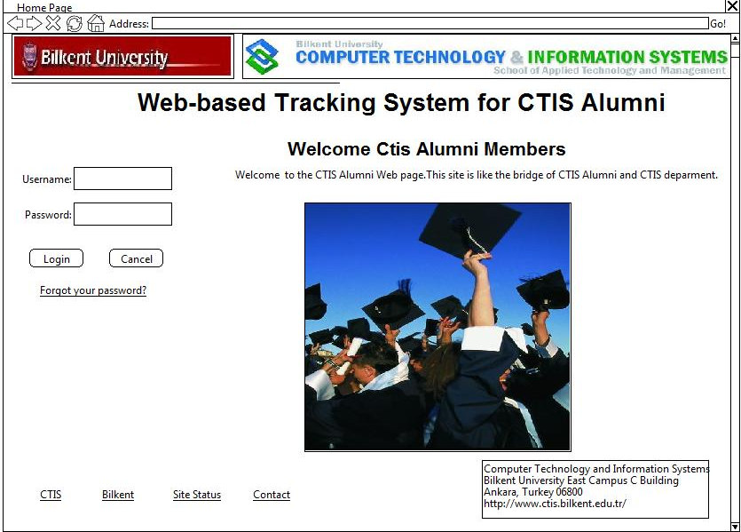

Name of item: | The login page of the Web-Based Tracking System for CTIS Alumni.
Description of the purpose: | The confirmation mechanism of the system.
Source of input(s): | System administrator.
Relationships to other input(s)/output(s): | The username and passwords is being matched in system.

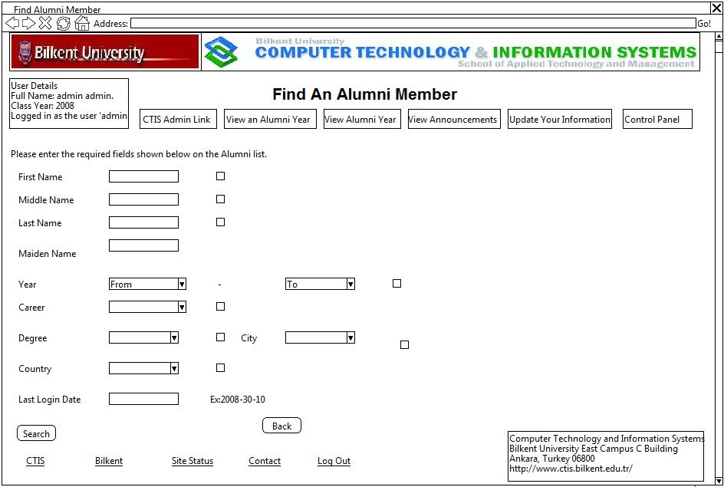

Name of item: | Search alumni page of Web-Based Tracking System for CTIS Alumni.
Description of the purpose: | Find alumni in specific criteria.
Source of input(s): | System administrator and CTIS alumni.
Relationships to other input(s)/output(s): | Alumnus’ informations must be existing in the system.

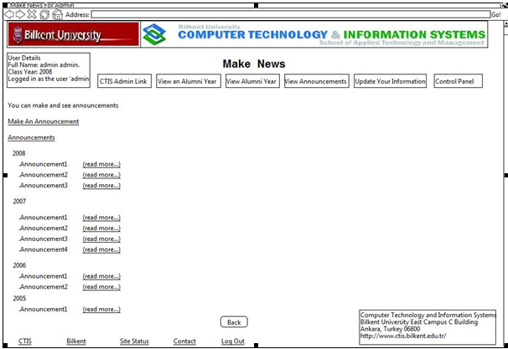

Name of item: | Make an announcement of Web-Based Tracking System for CTIS Alumni.
Description of the purpose: | User can make and view the announcements.
Source of input(s): | CTIS Alumni
Relationships to other input(s)/output(s): | User must get authorization from System administrator to make an announcement.

Analysis Object Model

The Object Oriented Analysis helps us to understand system functionality which is required. The Object Model diagram tells us information and relations between the classes and also includes a few kind of user interface mock-up. In this system Object Modeling defines firstly, system administrator creates system user and user login to system. Secondly, admin controls the control panel and for that reason system maintained control panel. Thirdly, user creates announcements and admin confirms announcements and then announcements go to system.

