SOFTWARE DESIGN DESCRIPTION
FOR
WEB-BASED TRACKING SYSTEM FOR CTIS ALUMNI
(Team – 19)

Acquirer : Ayşin Solak ÖRKÇÜOĞLU
Team Members : Bengü KARAKOÇ
Bora KORKMAZ
Burçak AYDIN
Gizem SELEK

Revision : 1.0

Due Date : January 05, 2009

Signatures:

_________________________
Bengü KARAKOÇ – Group Manager

_________________________
Bora KORKMAZ – Group Member

_________________________
Burçak AYDIN – Group Member

_________________________
Gizem SELEK – Group Member

_________________________ __________________________
Beyhan Akporay Ayşın Solak ÖRKÇÜOĞLU
Senior Project Manager Project Consultant
Change History

Date | Version | File Name | Document Format | Status
04/01/2009 | 1.0 | Team19_SDD_v1.0en.doc | MS Word | Created

TABLE OF CONTENTS

1 Introduction 6
1.1 Overview 6
1.2 References 6
1.3 Definitions and Acronyms 7
2 Design Considerations 7
2.1 Assumptions 7
2.2 Constraints 8
2.3 Design Methodology 9
3 System Overview 10
3.1 System Structure 10
3.1.1 External Interfaces 10
3.2 System Functionality 12
3.3 Software Products 14
4 System Design 14
4.1 Design Goals 14
4.2 System Decomposition 15
4.3 Subsystems Mapping 17
4.4 Data Management 19
4.5 Security Management 19
4.6 Control Flow 20
4.7 Boundary Conditions 21
5 Object Design 22
5.1 User Management 22
5.1.1 Package Description 22
5.1.2 Design Class Diagram 23
5.1.3 Sequence Diagram(s) 24
5.1.4 State Diagram(s) 25
5.2 User Directory 26
5.2.1 Package Description 26
5.2.2 Design Class Diagram 27
5.2.3 Sequence Diagram 28
5.2.4 State Diagram(s) 29
5.3 Search Management 30
5.3.1 Package Description 30
5.3.2 Design Class Diagram 31
5.3.3 Sequence Diagram 32
5.4 Announcement Operations 33
5.4.1 Package Description 33
5.4.2 Design Class Diagram 34
5.4.3 Sequence Diagram 35
6 Traceability Matrix 36
7 Other Design Features 38

LIST OF FIGURES

Figure 1 : Overview and interaction with external interfaces. 11
Figure 2 : Use Case Model/Context Diagram for Admin 12
Figure 3 : Case Model/Context Diagram for Alumni 13
Figure 4 : Layered view of the internal structure of the subsystems 16
Figure 5 : subsystem mapping of WTS for CTIS alumni. 17
Figure 6 : Interaction between Customer computer,WebServer and DatabaseServer 18
Figure 7 : User Management Class Diagram 23
Figure 8 : Sequence Diagram of User Management 24
Figure 9 : State Chart Diagram of User Management 25
Figure 10 : Class Diagram for User Directory Package 27
Figure 11 : Sequence Diagram for User Directory Package 28
Figure 12 : State Diagram for User Directory Package 29
Figure 13 : Class Diagram for Search Management Package 31
Figure 14 : Sequence Diagram for Search Management Package 32
Figure 15 : Class Diagram for Announcement Package 34
Figure 16 : Sequence Diagram for Announcement Package 35
Figure 17 : Modular View of Package Diagram 38

Table 1 : Traceability Matrix Table 37

Preface

This document is the Software Design Document of Web-based Tracking System for CTIS Alumni. The WTS system is web-based tracking system that will allow keeping information CTIS students after their graduation and the department can reach their alumnus information’s. The main aim of this system that creating connection between CTIS alumnus and departments. And also system will allowed to alumnus following news about their old friends and department or sending e-mail by administrator who should be control or authorized.

This document involves understanding the functions and constraints in terms of product’s specification and also understanding the relationship with goals about it. Applying the following stages for this document will be helped to evaluate the success of the project.

Introduction

Overview

This document describes the WTS for CTIS Alumni software structure in detail, and how the system will be structured and implements the satisfied requirements which are placed in Software Requirements Specification. The Software Design Description (SDD) document provides to describe and specifies the necessary information content for software designs of Web-based Tracking System of CTIS Alumni. This document will be a translator of system requirements into software design, user interfaces, system components and data’s for implementation. This means, how system structure, interfaces, design inputs, design constraints, data structures and also operating system will be integrated into code in implementation phase. The major purpose of this document is how system will satisfy the requirements identified in the SRS. The indented audience of this document will be SW developers.

References
- IEEE Std 830-1998, IEEE Recommended Practice for Software Requirements Specifications.
- CTIS459 Web Page, http://www.bilkent.edu.tr/~bakporay/ctis_459/ctis_459.html
- SRS (Software Requirements Specification) of the Web-based Tracking System for CTIS Alumni, version 1.0.

Definitions and Acronyms
SDD: Software Design Description
SRS: Software Requirements Specification
CTIS: Computer Technology and Information Systems
IEEE: Institute of Electrics & Electronics Engineering
MySQL: (My Structured Query Language) A database management system.
C#: A programming language introduced by Microsoft.
ASP.Net: Web programming technology.
WTS: Web-based tracking system.
SW: Software.
UML: (Unified Modeling System) An object oriented design language.
GUI: Graphical User Interface.
DBMS: Database Management System.

Design Considerations

Assumptions
- Required server for operating the system will be provided by the department.
- This product is only used by CTIS department.
- Department of CTIS will provide access to the data from database of country and city.

Constraints
In this document shall be indicated in case of identifying any constraints in the system design and contingencies that might arise in the design of the system. Therefore, it will be possible to change the development direction.

The software project’s constraints as below:

- The primary constraint of the software project is that the database shall be an open-source freely available DBMS.
- The software implementation language shall be used C# language so it will be required to use higher operating system with .NET Framework 2.0.
- Microsoft Visio is decided to be used for modeling of the project and also Microsoft Project is decided to be used for management of the project.
- Altova tool is used for creating class diagrams and package diagrams especially.
- All end- user interfaces of the Web-based Tracking System for CTIS Alumni must be appropriate in every operating system.
- The whole functions of the system can be used by admin or alumni who will be authorized in restricted cases.
- During running WTS system over internet, users have limited time and boundaries of the project are limited with Local Area Network environment.
- In case of safety and security shall be done and shall be provided after detail research.
- Backward Compatibility and recovery shall be provided.
- The system shall be depend on the department and also shall be compatible Internet-based, operated in independent platform.

The software development processes and documentation will be in compliance according to IEEE standards. In detail, the naming of the classes, database fields, attributes, tables and interfaces are named compatible with IEEE Std 830-1998, IEEE Recommended Practice for Software Requirements Specifications.

Design Methodology
During the designing the system, “Object-Oriented Methodology” and “UML Diagrams” are used for designing. Basically software methodology is based on “Object-Oriented Paradigm”.
During the object-oriented analysis, the main purpose is that finding and describing the objects or concepts which are in the problem domain. On the other hand, during object oriented design, the precise purpose is that defining software objects and how they collaborate to fulfill requirements. It is the well-known fact that system functions are defined by set of use-cases and these use-cases helps to indicate system functions, actors of the system and also these use cases will be determined functions of system and actors, who are like a human, machine, etc., will be interact with the system directly. Thus, the system shall use object-oriented methodology through .NET developer tool which is used C# as a programming language in base code development. In addition, Microsoft Visual Studio 2008 will be used in case of developing web-based code and also MYSQL database system will be used in case of database implementation of “Web-based Tracking System for CTIS Alumni”.

System Overview

System Structure

External Interfaces

The first and the major external interface for user is web interface; that consists of ASP.Net pages and CSS technologies. This part is needed by customer to know how WTS for CTIS alumni have a interaction with other external applications.
Web interfaces: web interface will include programming power of ASP.Net and site layout of CSS for designing pages.

Since WTS for CTIS alumni is a standard web application so it will be deployed in ASP.Net developer web server. Also there is a server that provides handle all database information from database server that is CTIS server. Web applications both need web browser and database server. Database server can in same machine or another outsourced machine.
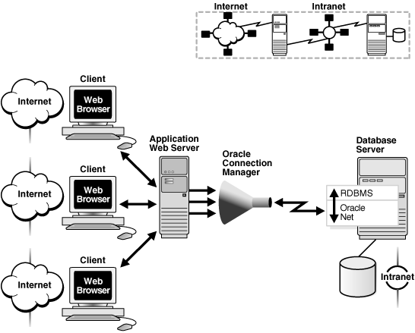
Figure 1 : Overview and interaction with external interfaces.

- WTS for CTIS alumni gets past years alumnus information in CTIS Database.
- WTS for CTIS alumni receives modified information and deliver to CTIS database.

System Functionality

WTS for CTIS alumni has many functionalities which are shown in figure 2 and figure 3 (use case context diagram).

Figure 2 : Use Case Model/Context Diagram for Admin

Figure 3 : Case Model/Context Diagram for Alumni

Software Products
System has 2 software products. Which are;

- An executable WTS system,
- System, Unit and Integration test cases.

System Design

Design Goals
From the eight issues of system design, first issue is identify design goals. These goals, which are mentioned in software requirements specification document, are non functional requirements of the product. Our system design will be implemented due to the design goals and their trade offs which are listed below.

Reliability: Reliability is the ability of to maintain the required functions under any circumstances. If the any changes (design, functions, data etc.) will be occurred in the WTS, the testing team should test all the changes done. Implementing the process of the system will be tested and coded concurrently.

High-Availability: For the reason, WTS is a web-based program so the connection is the most important feature of the system which has a department database and application server. If any problem will be occurred on database or internet connection, it may lead to cause problems on the system. The CTIS department will be responsible the control of the database server so database must be available in any circumstances and also internet connection must be available.

Minimum number of errors: Firstly all developers have a design goal for minimazing the number of errors in implementation phase. World wide open source software which is W3C, will be used for decreasing the errors because of wrong algorithm. Also Oracle database will be used for detailed processing.

Security: WTS is an internet application so there may be many attacks to the system. Admin have many privileges to prevent these attacks. For instance, admin can change site status against these attacks. In addition, if alumnus do not want to show their individual information, they will hide those information and the hidden fields can not be seen by the other alumnus.

Accessibility: Only admin can access and change all the alumnus individual information.
Ease of use: Through web browser, any of the user can use this system via the internet.GUI helps user to access the system informations easily and fastly.
Portability: WTS is installed to any computer which has a windows operating system. The user enters this software product’s web site in any computer in other words; typing the internet address to the address bar will be enough.

Maintainability: Maintainability is the process of modifying the software product and also will be upgraded according to customer requirements which are requested by customer. if the customers want to add new modules to the project, the acquirer and developers shall make a new agreement. As a result of this, developers will be modified the whole system according to new agreement. Besides, the projects maintainability should be easily integrated changes in new modules and new technological solutions for the system.

System Decomposition
Identification of the subsystems of WTS for CTIS alumni is equal to functional model of the system. Functional model is derived from the functional requirements which are placed in Software requirements specification (SRS) document. Object model of our system which includes objects and classes are being a seed for our subsystems. The purpose of identifying the subsystem is divided systems into components and each of components is managed by different user. In UML subsystems are modeled as packages so below is the UML package diagram of the WTS for CTIS alumni. There two views for functionality of the system:

- Modular view
- Layered view

The subsystems of WTS for CTIS alumni are derived from the functional requirements which are placed in Software requirements specification (SRS) document. In WTS for CTIS alumni has 4(four) subsystems. Above is the diagram of the system decomposition.

Figure 4 : Layered view of the internal structure of the subsystems

The subsytems of WTS for CTIS alumni are;
- User Management
- User Directory
- Search Management
- Announcement

User Management: Administrates the user accounts.
User Directory: Stores the user profiles
Search Management: The Search Management package is divided into two other subsystems.
- Announcement Search: User can see the announcements by searching the years of the announcements.
- User Search: User can search other users by using the user information criteria.

Announcement: User can request announcements, and see them on the announcement search criteria.

Subsystems Mapping
WTS for CTIS alumni is an online system, therefore it can be only used and accessed for web browser from any computer. These computers which are accessed to this system have a web browser with attach to internet. Web browser is software application that enables users display web pages at a Web site. Therefore, there is no need for any installations for accessing and using WTS for CTIS alumni. There are two(2) nodes.

One of them will be the customer computer. The other one is the web server machine. There will be no external hardware such as databases. Because our database will be in the same place with CTIS server machine. Above is the abstract figure of the subsystem mapping of WTS for CTIS alumni.

Figure 5 : subsystem mapping of WTS for CTIS alumni.

Web server side of the WTS for CTIS alumni will include DatabaseServer and the system’s subsytems. Our system will have four (4) subsytems. These subsytems will be developed in ASP.Net. CTIS Server Machine. Provides the database interfaces. In theoric, DatabaseServer and WebServer are not in the same place. However, in application our system has a must to Database and CTISServer are in the same place.Microsoft Windows Vista will be the operating system of our system in the WebServer machine.

Below table shows the interaction between nodes(Customer computer,WebServer and DatabaseServer). Customer computer’s will display the pages with Internet Explorer 6.0. Internet Explorer will be adequate for the side of CustomerComputer. Web browser will attaches the CTISWebServer with http. There is no need for an external hardware. Because, our web server and database are located in same place. Database will be an internal hardware CTIS server.

Figure 6 : Interaction between Customer computer,WebServer and DatabaseServer

Data Management

Database tables will be developed by MySQL and C#, .Net will be used for providing the connection of the database.

- While the admin registers a new account, new account’s data is stored in the database.
- Admin and users information are kept in the same database.
- While entering the system with user id or personnel id and password, these private data’s validity are checked by the database of the system.

Each table and its fields have a unique and explanatory name in the database of the system to prevent the complexity.

Security Management

The project’s web security should be provided because of depending on department. Thus, maintaining security of system must be implemented login control which user will enter their user id and password on the web-site. In addition, confirmation mail is sent to user’s mail which includes both numbers and characters in case of providing security. Only instructor and the students of CTIS department give authorization in case of login the system so the system has two types of users, who are admin and alumni, so there are different levels of authorization. When the user has been entered individual information’s which can not be seen any other users without admin.

In case of security, admin controls the system and database. On the part of database, only admin makes any changes such as editing, deleting or removing user or data.

Control Flow

The Control Flow should describes how requests are initiated and how subsystems synchronize and also control flow indicates sequence of system’s operations, that is to say, when the request is sent by client, system should be evaluated and fulfill the necessary process in case of responding client request. Therefore, the sequence of the action of web-based tracking system eventuates, in three control phase.

First of all, user should connect to system after they get their temporary user name and password which are sent user’s individual e-mail addresses. There will be an interface which requires users to enter their login name and password. Then the system checks the database and if the user will be specified, related interface should be displayed. After checking user’s authorization control, users should perform related operations such as completing form which requires filling in the individual information. If the user should makes necessary changes in their information, she/he should save the changes by using save changes button which is available in the interface.

The other most important fact that system have to support multi-user system because too many users try to login at the same time, that is to say, a few user can be used the system and do same operations at the same time. In addition, a few admin also try to access to the database at the same time and implement to the same assignment probably.

This system will be used when two kinds of users, who are admin and alumni, want to use. For instance, admin wants to add a new alumnus or implement any operations and alumni want to do any operations. They also want to these operations at the same time so thread will be used in case of providing these functions to the users.

Boundary Conditions

There are three conditions of the system boundaries. These are Initialization, Termination, and Failure.

Initiation phase indicates the dynamic model of the system start-up. First of all, system server must be available in case of start up and shutting down that a client is done to connection with the system. In addition, it is the undeniable fact that user can only startup and shutdown a connection with the system by using web browser application however phone and internet connection must be received attention. For starting system and only the system administrator, who are responsible for monitoring the server, can startup the system. When the system starts up, database and other subsystem will be started automatically. Thus, database has to be running perfectly. On the other hand, the shut down the system can also performed by the administrator. When the system will shut down, the database and related subsystem will shut down atomically. In addition, the “maintenance” of the system should be performed. Before login the system, user enters the password on the websites, the system will be sent the password to server through application server and checks data. If the password is valid that entered by the user and shows the user’s information website which is required to fill user’s information.

The termination part of the boundary conditions explain subsystems which will be allowed to terminate and also will be updates communicated to the database when the systems or subsystem terminates. It is the well-known fact that termination of the subsystem is done by the users. For instance, the user of the system can edit data or update data. If any update operations will be occurred, users will be direct to website to implement updates in case of informing about related changes.

The failure part of boundary condition mainly depends on communication problems, that is to say, this is a web-based system and all connection operations depend on internet and phone. If the electricity has gone, all the processes have been lost. In addition, the main points of these failures are prevented using or existing backup files which are available for database especially.

Object Design

User Management

Package Description

In WTS for CTIS alumni product, there is an administrator who has a right to manage this web site. It means that administrator has a high authority for doing some operations. User Management operation is one them for the responsibility of administrator. This package has a purpose of administrate user accounts. There are two types of users. One of them regular alumni the other one is the administrator. Also site status class checks the site’s situation. If in site status registration is disabled, admin will not create a user account. This package has an objective for creating, deleting and editing the user accounts. Therefore, this package has 9 classes.

Design Class Diagram
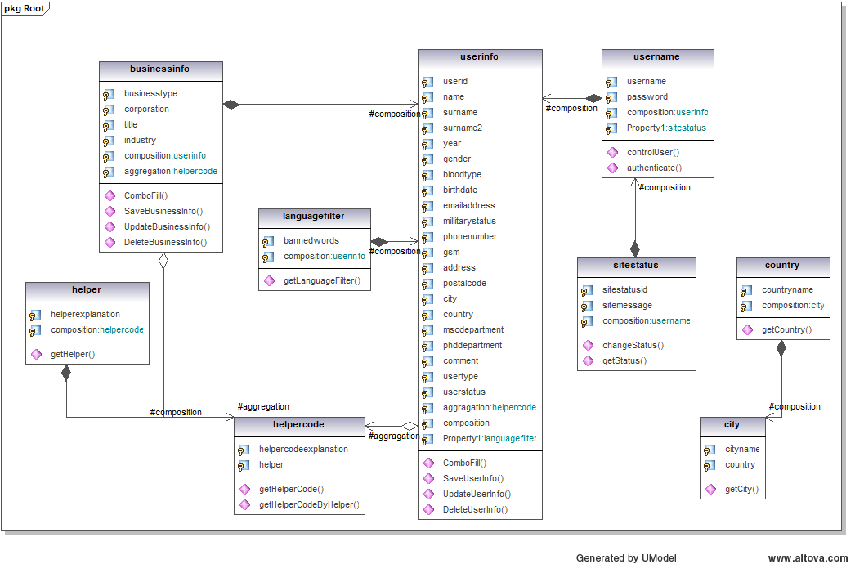

Figure 7 : User Management Class Diagram

Sequence Diagram(s)

Figure 8 : Sequence Diagram of User Management

State Diagram(s)

Figure 9 : State Chart Diagram of User Management

User Directory

Package Description

In WTS for CTIS alumni product, there are 2 types of user information. One of them is the admin user information the other one is the alumni information. These are different from each other at one point. In admin information personnel id is the must, however in alumni information student id is the must. Also site status class checks site’s situation. If site status is offline, user can not enter the site.

This package contains the user information. It means, it has a purpose for storing and managing the user profiles. Administrator has a right for managing the alumnus and own profiles; however alumni has a right for managing only own profile. There are 8 classes in User Directory package. Above figure shows the classes of User Directory package and their relationships.

Design Class Diagram

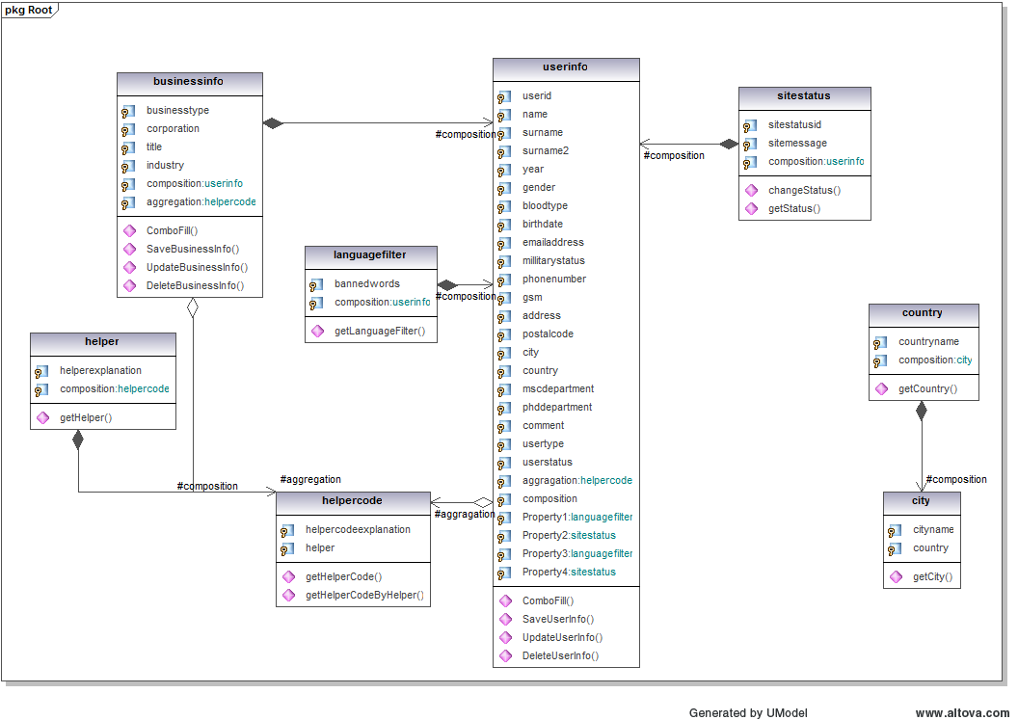

Figure 10 : Class Diagram for User Directory Package

Sequence Diagram

Figure 11 : Sequence Diagram for User Directory Package

State Diagram(s)

Figure 12 : State Diagram for User Directory Package

Search Management

Package Description

In WTS for CTIS alumni product, Search operations have a big function. According to user types search management mechanism will be changing. This package has 2(two) branches. User search and announcement search. Administrator has a right to see the hide information’s. If alumni or different administrator checks the hide boxes in user information, administrator will see the hide information’s when searches a user. 2(two) types of user can search at the same situation. These situations may be one category from business information class or one category for user information class or all of them.
In announcement search, a user selects a year for what he/she wants to see the announcement. This package has purpose for operate the search mechanism. This package has 8 classes.

Design Class Diagram

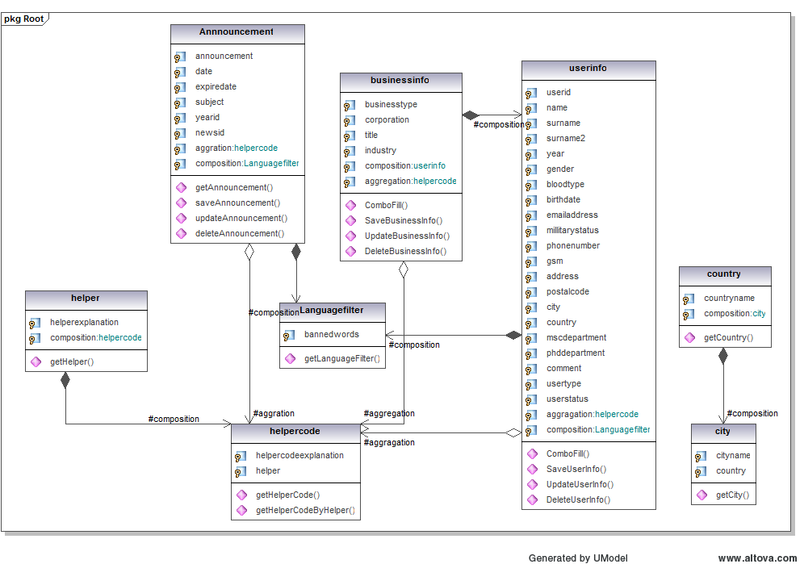

Figure 13 : Class Diagram for Search Management Package

Sequence Diagram

Figure 14 : Sequence Diagram for Search Management Package

Announcement Operations

Package Description

In WTS for CTIS Alumni product, Administrator has a right for managing the announcements. The purpose of its package, if an alumni send an announcement request, admin will check this will be an appropriate announcement or not. If it is appropriate admin will publish announcement. Also language filter class checks the banned words of the announcement. Alumni can view the announcements by searching announcements by years. All announcements have an expired date in order to be deleted by own.

Design Class Diagram

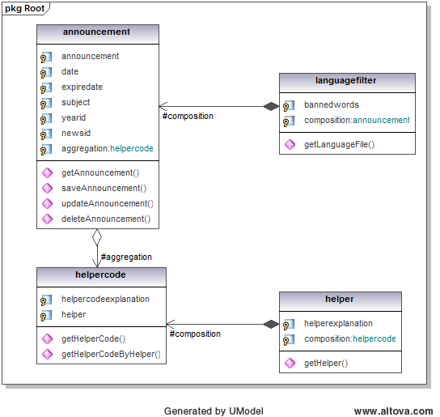

Figure 15 : Class Diagram for Announcement Package

Sequence Diagram

Figure 16 : Sequence Diagram for Announcement Package

Traceability Matrix

The traceability matrix assures that every requirement has been addressed in the design and every design element addresses a requirement.

Design Elements are:
- User Management
- User Directory
- Announcement
- Search Management
Requirements Identification  (SRS) | Design Elements
  1 | 2 | 3 | 4
3.1.2
  x
3.1.3
  x
3.1.4
  x
3.1.5
  x
3.1.6
  x
3.1.7
   | x | x
3.1.8
  x
3.1.9
  x
3.1.10
  x
3.1.11
  x
3.1.12
  x | x
3.1.13
  x

Table 1 : Traceability Matrix Table

Other Design Features

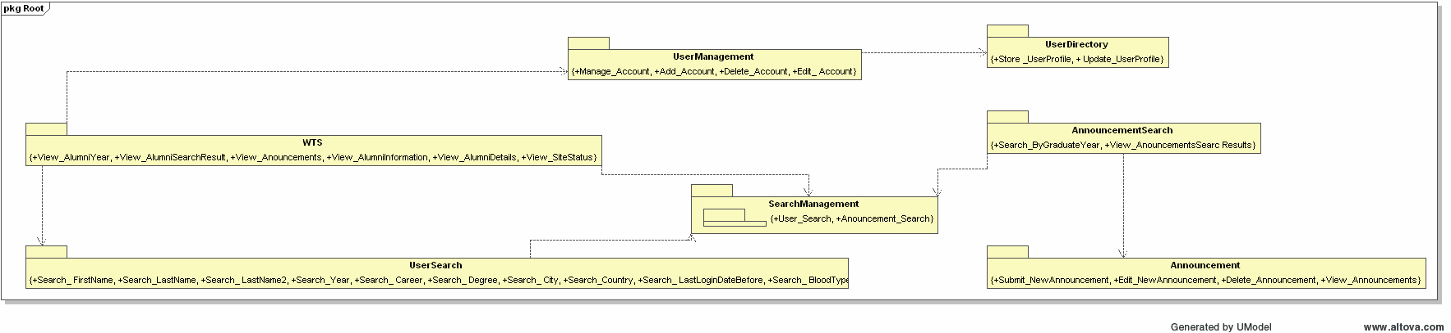
Figure 17 : Modular View of Package Diagram

